**PRESS RELEASE**

Freudenberg pushes the limits of innovation with Evolon® New Generation

**Colmar, France, 23.11.2017. Building on the success of the company’s unique Evolon® product, Freudenberg Performance Materials has now pushed the limits even further by developing Evolon® New Generation. This high-tech textile is made from super-microfilaments that are half the thickness and twice the density of those used in the original Evolon®. Evolon® New Generation complements the original Evolon® by opening up entirely new applications in the fields of bedding, technical packaging and many others.**

**Ultra high-performance**

Thanks to a perfect balance of breathability, permeability to water vapor and thermal insulation, Evolon® New Generation provides the best combination of thermo-physiological properties for unparalleled comfort.

The new textile is twice as dense as the original version, significantly increasing its filtration performance. Whereas the original Evolon® is already a perfect solution for the manufacture of anti-mite encasings that help allergy sufferers, Evolon® New Generation now provides a specific solution to make feather-filled pillows and quilts, filtering even tinier allergens, dust particles and down filling.

**A new feeling of luxury**

With its premium appearance and luxury feel, Evolon® New Generation complements the original Evolon® by creating a new product for top-quality bed linen. The original Evolon® remains ideally suited for purely technical applications, like anti-mite encasings.

Because the super-microfilaments are twice as fine as the original material, Evolon® New Generation has become a much softer and non-abrasive technical packaging material, ensuring maximum protection for even ultra-sensitive surfaces.

**Long-lasting and sustainable**

As well as its functional benefits, Evolon® New Generation helps to conserve resources. The super-microfilaments are 200 times thinner than a human hair, making the new textile remarkably resistant to mechanical stress, abrasion and repeated washing. This improved durability keeps the fabric looking good and maintains consistent performance, wash after wash.

Because it is much lighter than traditional textiles, the new super-microfilament textile also enables professional laundries to improve their eco balance. In addition, no solvents or binding agents are used in the production process and far less water is consumed than for producing conventional cotton-based fabrics.

**New applications awaiting approval**

Jean-François Kerhault, Evolon Business Segment Manager, talked about the new product’s potential: “We are only beginning to explore the possibilities of Evolon® New Generation. We have already identified applications that, up to now, were way beyond the scope of our original microfilament technology. For example, bedding filled with down and feathers, high-end bed linen and packaging for ultra-sensitive parts. Other opportunities should be receiving approval within the next few months. In fact, the technical possibilities are enormous.”

Kerhault was keen to point out that the original version of Evolon® is a major pillar in the overall product range: “Evolon® original microfilament textiles apply especially in applications and industries where they are already well established. Alongside anti-mite bedding, technical packaging and industrial high-tech wipes, typical applications include automotive acoustics, products for the printing industry, cosmetics and many more.”

**Versatility and quality**

Like the original Evolon®, the super microfilament textile is available in a wide range of weights and variations, allowing it to be adapted to the specific requirements of different uses. Manufacturers will appreciate how easy it is to process Evolon® New Generation. Non-fraying edges mean that there is no need to hem the fabric, and it can be dyed, printed and sewn just like any other textile.

Evolon® is manufactured in Europe according to ISO 9001, ISO 14001 (environment), ISO 50001 (energy consumption) and OHSAS 18001 (health and safety).

**Picture**

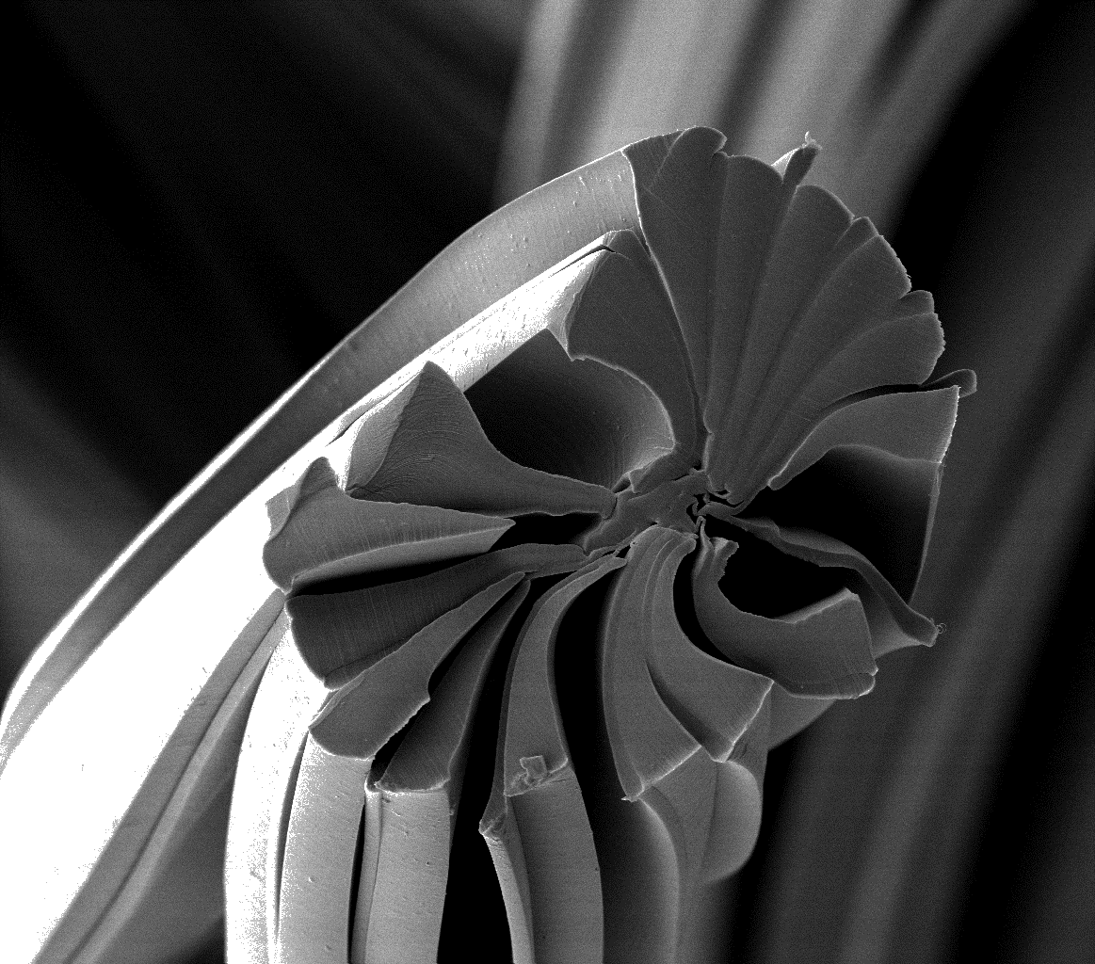

*Evolon® New Generation super-microfilaments*

**Contacts for media enquiries**

Freudenberg Performance Materials Holding SE & Co. KG

Holger Steingraeber, Director Global Communications

Höhnerweg 2-4 / 69469 Weinheim / Germany

Ph. +49 6201 80 6640

[Holger.Steingraeber@freudenberg-pm.com](mailto:Holger.Steingraeber@freudenberg-pm.com)

[www.freudenberg-pm.com](http://www.freudenberg-pm.com)

Freudenberg Performance Materials sas

Isabelle Kugler

20 rue Ampère / 68000 Colmar / France

Ph. +33 3 89 20 64 79

[Isabelle.kugler@freudenberg-pm.com](mailto:Isabelle.kugler@freudenberg-pm.com)

[www.evolon.com](http://www.evolon.com)

Please send publication copies to this address

About Freudenberg Performance Materials

Freudenberg Performance Materials is a leading global manufacturer of innovative technical textiles offering differentiated value propositions to a broad range of markets and applications such as Apparel, Automotive, Building Materials, Hygiene, Medical, Shoe and Leather goods as well as Specialties. In 2016, the company generates sales of more than €950 million and has 25 manufacturing sites in 14 countries and almost 3.800 employees. Freudenberg Performance Materials attaches great importance to social and ecological responsibility. For more information, please visit www.freudenberg-pm.com

In 2016, the Freudenberg Group employed more than 48,000 people in almost 60 countries worldwide and generated sales of approximately €8.6 billion (including pro-rata consolidation of 50:50 joint ventures). For more information, please visit www.freudenberg.com