**PRESS RELEASE**

**Battery Pack Liquid Absorbers make batteries safer**

**Weinheim, Germany, 24 June 2021.** **Water condensation and potentially leaking coolants inside lithium-ion battery packs can significantly diminish their function and lifetime. Freudenberg Performance Materials developed its Battery Pack Liquid Absorbers to prevent such problems.** **The absorbent pads capture and reliably store unwanted liquids. With adjustable absorption capacity and custom geometries, Battery Pack Liquid Absorbers ensure long-lasting battery packs.**

Battery packs are the core elements of mobile and stationary lithium-ion energy storage systems in automotive and industrial applications. The performance and lifetime of these components are largely responsible for the efficiency of the energy storage system. Moisture and liquids occurring inside the packs can considerably damage them. Here, the humidity of the air is one major issue. Air enters into the battery pack, and creates condensation inside the cooled pack. Another problem is coolants which may accidentally leak out of the cooling system. In both cases, Freudenberg´s Battery Pack Liquid Absorbers act as a safety system to reliably capture and retain condensate and leaking coolants.

**Absorbent pads reliably take up moisture**

Freudenberg´s Battery Pack Liquid Absorbers are absorbent nonwoven pads endowed with fast liquid take-up and high retention capacity. Even in an emergency, leaking coolants are quickly absorbed and reliably retained. The modular design of the pads allows for scaling of the absorption capacity, which is limited only by the available space. Customer-specific geometries can even be implemented thanks to the flexible material.

“As liquid-cooling systems are prevailing to deliver efficient thermal management for high power batteries, we believe that our Battery Pack Liquid Absorbers will become a must-have safety component of future high-voltage systems,” says Thomas Petzel, General Manager Freudenberg Performance Materials SE & Co. KG.

Picture:

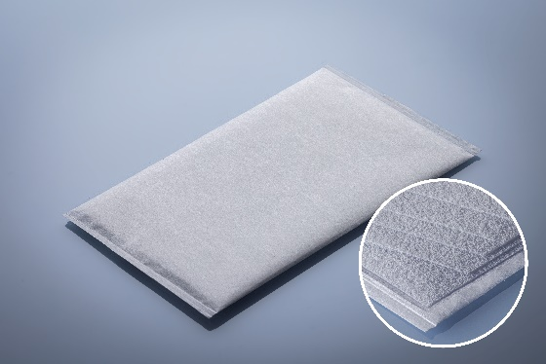

Battery Pack Liquid Absorber, with zoom on inside multilayer construction.

Contact for media inquiries

Freudenberg Performance Materials Holding SE & Co. KG

Holger Steingraeber, Director Global Communications

Höhnerweg 2-4 / 69469 Weinheim / Germany

Phone +49 6201 80 6503

Holger.Steingraeber@freudenberg-pm.com

www.freudenberg-pm.com

Katrin Böttcher, Manager Global Media Relations

Höhnerweg 2-4 / 69469 Weinheim / Germany

Phone +49 6201 80 5977

Katrin.Boettcher@freudenberg-pm.com

www.freudenberg-pm.com

About Freudenberg Performance Materials

Freudenberg Performance Materials is a leading global supplier of innovative technical textiles for a broad range of markets and applications such as apparel, automotive, building interiors, building materials, healthcare, energy, filter media, shoe and leather goods as well as specialties. In 2020, the company generated sales of more than €1 billion, had 33 production sites in 14 countries around the world and had some 5.000 employees. Freudenberg Performance Materials attaches great importance to social and ecological responsibility as the basis for its business success. For more information, please visit [www.freudenberg-pm.com](http://www.freudenberg-pm.com)

The company is a Business Group of Freudenberg Group. In 2020, the Freudenberg Group employed more than 48,000 people in some 60 countries worldwide and generated sales of more than €8.8 billion. For more information, please visit [www.freudenberg.com](http://www.freudenberg.com)