**PRESS RELEASE**

**Three functions in one product: New geogrid composite saves up to 50% of installation time**

**Arnhem, the Netherlands, 25 January 2022 – Freudenberg Performance Materials, a leading global supplier of high-performance geosynthetics for the civil engineering market, presents a new geogrid composite. Aimed at increasing the efficiency of construction projects, the product consists of a reinforcing grid bonded to a separation and filtration nonwoven geotextile.** **Customers can obtain the new geocomposite EnkaGrid MAX C as of now. It is part of the Enka Solutions range for civil engineering applications.**

When weak subgrade soils are present, most infrastructure projects such as the construction of traffic areas require installation of two products: a geogrid to reinforce the granular layers of the subbase and a nonwoven geotextile for filtration and separation. “This means that the same work has to be done twice to purchase two products, get them to the site, manage stock and lay the geogrid and the nonwoven geotextile,” explained Tamás Szatmári, Head of Application Management. “By providing the three required functions in one product, EnkaGrid MAX C substantially cuts complexity and costs for every stakeholder involved. Installation, for example, can be completed up to twice as fast.”

EnkaGrid MAX C is made up of a biaxial geogrid bonded at intervals to a needle-punched nonwoven geotextile. The bonding method chosen guarantees optimal interlocking of granular soils with the geogrid.

EnkaGrid MAX C can be ordered in tensile strengths ranging from 20 to 80 kN/m. It is supplied on rolls with a width of five metres. “The geogrid composite comes with extensive support offered by our team of experienced Application Managers. They assist engineers and clients from feasibility study to design and execution.”, concluded Szatmári.

Pls. find more information on [EnkaGrid MAX Conour website](https://bit.ly/3FJ6ew5)

*Photo attached:*

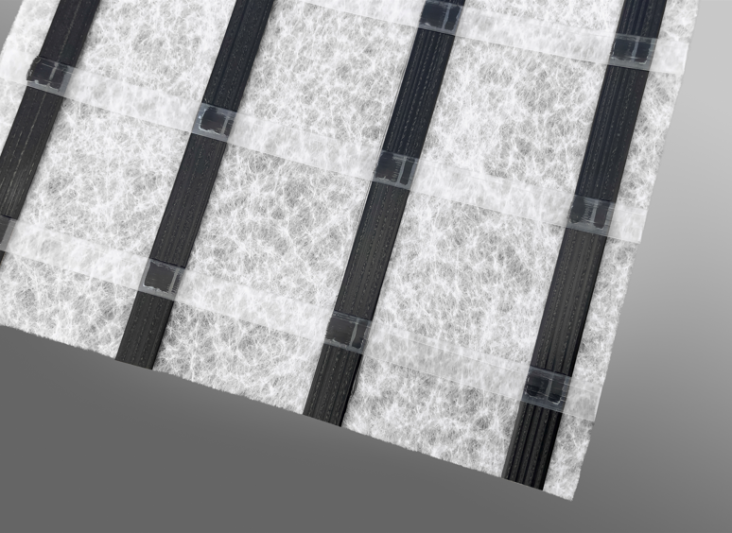 *EnkaGrid MAX C geogrid*Copyright Low and Bonar bv

Contact for media inquiries

Freudenberg Performance Materials Holding SE & Co. KG

Holger Steingraeber, SVP Global Marketing & Communications

Höhnerweg 2-4 / 69469 Weinheim / Germany

Phone +49 6201 80 6503

Holger.Steingraeber@freudenberg-pm.com

www.freudenberg-pm.com

Katrin Böttcher, Manager Global Media Relations

Höhnerweg 2-4 / 69469 Weinheim / Germany

Phone +49 6201 80 5977

Katrin.Boettcher@freudenberg-pm.com

www.freudenberg-pm.com

About Freudenberg Performance Materials

Freudenberg Performance Materials is a leading global supplier of innovative technical textiles for a broad range of markets and applications such as apparel, automotive, building interiors, building materials, healthcare, energy, filter media, shoe and leather goods as well as specialties. In 2020, the company generated sales of more than €1 billion, had 33 production sites in 14 countries around the world and had some 5.000 employees. Freudenberg Performance Materials attaches great importance to social and ecological responsibility as the basis for its business success. For more information, please visit [www.freudenberg-pm.com](http://www.freudenberg-pm.com)