**PRESS RELEASE**

Released for immediate publication

**ISPO 2022: Freudenberg presents sustainable product innovations for outdoor clothing, sports and active wear**

**Weinheim, Germany, November 16 – With optimum functionality and perfecting the fit, Freudenberg Performance Materials Apparel (Freudenberg) has positioned as a key partner to the sports industry. As one of the world's leading specialists in woven, knitted and non-woven interlinings and thermal insulation, the company presents sustainable solutions for sportswear and related product segments of all kinds. Freudenberg experts from Europe and Asia will be welcoming trade fair visitors at Stand 512 in ISPO Outdoor Hall A1.**

Trade show visitors will experience a wide range of innovative and sustainable interlinings for active sports outfits, stretch interlinings for yoga wear, Pilates & Co, and thermal insulations that combine perfect outdoor wearing comfort with high warmth retention. With comfortemp® brand thermal insulations and the Active Range, Freudenberg presents a complete package for outdoor and sportswear for winter sports: thermal insulations, interlinings, tapes, lining fabrics and adhesive solutions. Highlights include:

**comfortemp® protect HO 15x GRS**

The highly durable padding provides good warmth retention as well as high wearing comfort and withstands 25 cycles of industrial laundering. With a fiber content of at least 20 percent recycled PET bottles, comfortemp® protect HO 15x is certified according to the Global Recycling Standard (GRS).

**comfortemp® soft HO 80x**

The wadding offers the tailor-made solution for sustainable sports and outdoor applications. Made from 100 percent recyclable polyamide fibers (PA 6), comfortemp® soft HO 80x carries the "Gold level Health" certificate - awarding unlimited recyclability for a continuous and consistent circular economy.

**ISPO Textrends Award nomination for comfortemp® nature Lyocell HO 60x**

The independent jury has nominated the 100 percent biodegradable thermal insulation comfortemp® nature Lyocell HO 60x, made from Lyocell regenerated fibers, for the Textrends Award fall/winter 2024/25 season. The award is given exclusively to innovative products that are groundbreaking for the development of the textile industry. comfortemp® nature Lyocell HO 60x has a variety of extraordinary performance characteristics as a high warmth retention, bacteria inhibiting and fast drying, furthermore water repellent. High wearing comfort and the assurance of a perfect moisture balance characterize the volume fleece as ideal for the application in sportswear.

**High transparency in terms of sustainability**

Freudenberg is presenting its entire European and global product portfolio from its "House of Sustainability" at ISPO. The company is consequently taking a pioneering role in the transparent presentation of its entire portfolio of sustainable solutions. The "House of Sustainability" supports Freudenberg in minimizing its ecological footprint and maximizing its ecological handprint. For this purpose, the company's own manufacturing processes are designed to minimize the impact on the environment. In addition, products are developed to help customers produce more sustainably.

**Promoting transformation through joint innovation**

Freudenberg is committed to driving forward the ecological, economic and digital transformation process together with new and existing customers in the apparel industry. Freudenberg experts therefore also see ISPO as an excellent opportunity for talks and the exchange of ideas on possible collaborative developments.

Freudenberg Performance Materials at ISPO: **Hall A1, Booth 512**

**Image material:**

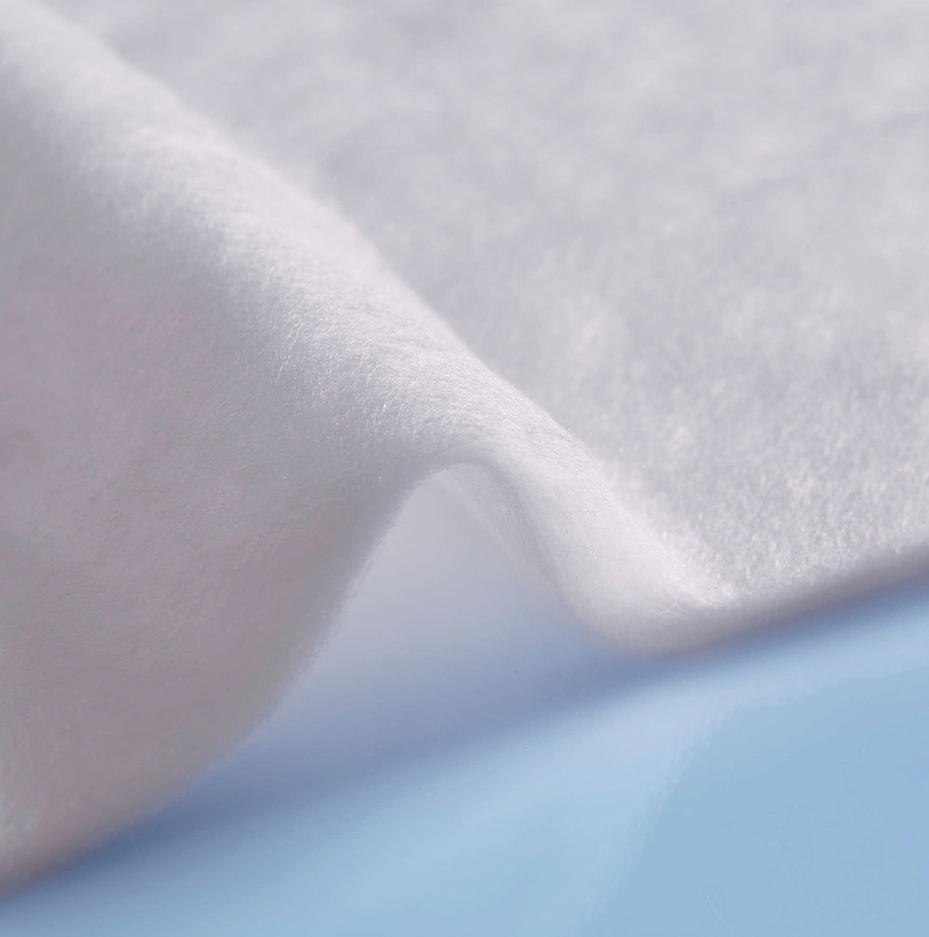

*Nominated for the ISPO Textrends Award Fall/Winter 2024/25: comfortemp® nature Lyocell HO 60X - the volume fleece with 100 percent biodegradability.*

Source: ©Freudenberg Performance Materials

**Contact for media inquiries:**

Freudenberg Performance Materials Holding SE & Co. KG

Holger Steingraeber, SVP Global Marketing & Communications

Höhnerweg 2-4 / 69469 Weinheim / Deutschland

Phone: +49 6201 7107 007

Holger.Steingraeber@freudenberg-pm.com

www.freudenberg-pm.com

Katrin Böttcher, Manager Global Media Relations

Höhnerweg 2-4 / 69469 Weinheim / Deutschland

Phone +49 6201 80 7107 014

Katrin.Boettcher@freudenberg-pm.com

www.freudenberg-pm.com

**About Freudenberg Performance Materials**

Freudenberg Performance Materials is a leading global supplier of innovative technical textiles for a broad range of markets and applications such as apparel, automotive, building interiors, building materials, healthcare, energy, filter media, shoe and leather goods as well as specialties. In 2021, the company generated sales of more than €1.3 billion, had 33 production sites in 14 countries around the world and had some 5.000 employees. Freudenberg Performance Materials attaches great importance to social and ecological responsibility as the basis for its business success. For more information, please visit www.freudenberg-pm.com

The company is a Business Group of Freudenberg Group. In 2021, the Freudenberg Group employed more than 50,000 people in some 60 countries worldwide and generated sales of more than €10 billion. For more information, please visit www.freudenberg.com