**PRESS RELEASE**

**Performance Days: Freudenberg Performance Materials to Present Sustainable Apparel Solutions**

**Weinheim, Germany, October 25, 2022 – Freudenberg Performance Materials Apparel (Freudenberg) will be part of the Performance Days from November 03 to 04, 2022 in Munich, Germany. The world’s leading specialist in woven, knitted, weft and nonwoven interlinings is pleased to meet visitors at booth no. T04, where the team will showcase the latest sustainable products for sportswear, workwear, sportive fashion and athleisure collections. Visitors will get the opportunity to experience a broad range of new materials combining sustainability, durability and performance.**

**Innovative and sustainable fabrics for the next winter season**

Freudenberg will showcase its full range of European and global products being part of its House of Sustainability, Active Range and the comfortemp® brand offering high-performance thermal insulation for outdoor and active wear. From recyclability to biodegradability and from functionality to comfort, Freudenberg materials meet many different requirements and help customers and end users achieve their personal goals.

Sustainability is one of Freudenberg’s key principles and thus reflected in all business activities. Freudenberg Performance Materials Apparel’s House of Sustainability strives to minimize the company’s footprint by reducing the environmental impact of the company’s manufacturing processes to a minimum. At the same time, Freudenberg maximizes its handprint by developing products enabling customers to manufacture more efficiently and sustainably or to consume fewer valuable resources. This initiative is based on seven product pillars with more than 500 sustainable products, among them recycled general interlinings, recyclable, energy-saving or biodegradable materials, sustainable cotton, nature-based solutions and recycled thermal insulations and linings.

The comfortemp® range clearly represents Freudenberg’s contribution to a sustainable future, from the use of renewable fibers to products made from 100% recycled polyester. These advanced technology materials combine high comfort with perfect thermal insulation properties and provide customers with different weights, fibers, hand feels and insulation levels.

Being part of the House of Sustainability, Freudenberg’s Active Range stands for high-performance solutions for stretch active and outdoor active wear including interlinings, tapes, linings, bonding solutions and measuring tools. Most materials of this portfolio are made of at least 70% recycled materials and thus cater to customers’ sustainability goals.

The experts of Freudenberg look forward to inform visitors about leading-edge solutions that enable them to produce their own products sustainably according to highest standards.

***Picture:***

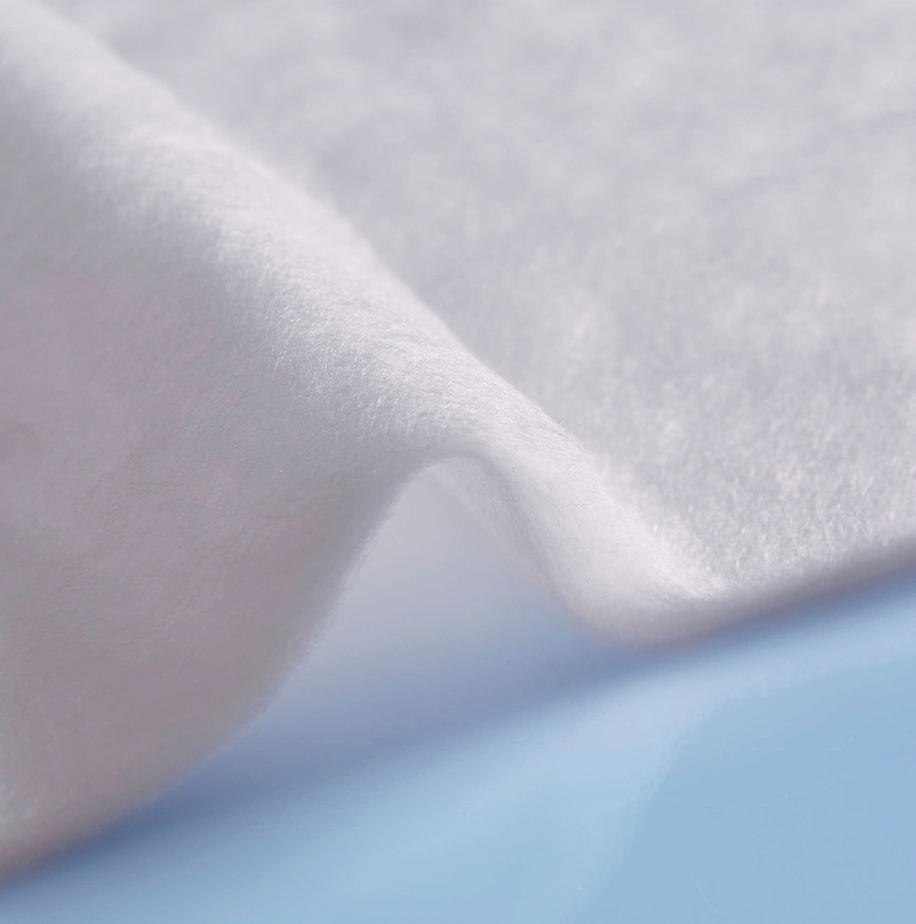

*comfortemp® nature Lyocell HO 60x is a 100% biodegradable wadding with high insulation performance.*

Source: ©Freudenberg Performance Materials

Contact for media inquiries

Freudenberg Performance Materials Holding SE & Co. KG

Holger Steingraeber, SVP Global Marketing & Communications

Höhnerweg 2-4 / 69469 Weinheim / Germany

Phone +49 6201 7107 007

Holger.Steingraeber@freudenberg-pm.com

www.freudenberg-pm.com

Katrin Böttcher, Manager Global Media Relations

Höhnerweg 2-4 / 69469 Weinheim / Germany

Phone +49 6201 80 7107 014

Katrin.Boettcher@freudenberg-pm.com

www.freudenberg-pm.com

About Freudenberg Performance Materials

Freudenberg Performance Materials is a leading global supplier of innovative technical textiles for a broad range of markets and applications such as apparel, automotive, building interiors, building materials, healthcare, energy, filter media, shoe and leather goods as well as specialties. In 2021, the company generated sales of more than €1.3 billion, had 33 production sites in 14 countries around the world and had some 5.000 employees. Freudenberg Performance Materials attaches great importance to social and ecological responsibility as the basis for its business success. For more information, please visit [www.freudenberg-pm.com](http://www.freudenberg-pm.com)

The company is a Business Group of Freudenberg Group. In 2021, the Freudenberg Group employed some 50,000 people in around 60 countries worldwide and generated sales of more than €10 billion. For more information, please visit [www.freudenberg.com](https://eur02.safelinks.protection.outlook.com/?url=http%3A%2F%2Fwww.freudenberg.com%2F&data=04%7C01%7CKatrin.Boettcher%40freudenberg-pm.com%7C4e6ece316c5b4cdd06cf08da115fcb53%7Cc7b0778106f341d7b40f5b2de1018509%7C0%7C0%7C637841400374918741%7CUnknown%7CTWFpbGZsb3d8eyJWIjoiMC4wLjAwMDAiLCJQIjoiV2luMzIiLCJBTiI6Ik1haWwiLCJXVCI6Mn0%3D%7C3000&sdata=Ie7Mo0DA5F5RDf5Qsh%2FCTH3acGvKyFOpn9pGGijkN1Y%3D&reserved=0).