**PRESS RELEASE**

Compamed 2022: Greater comfort and longer wear time with Freudenberg’s elastic superabsorbers for wound dressings

**Weinheim, October 27, 2022. Freudenberg Performance Materials (Freudenberg) has just launched an elastic variant of its flexible superabsorbers for modern wound dressings. These superabsorbers increase the comfort level for patients as well as enabling longer wear time, thus reducing the frequency of dressing changes. Freudenberg is debuting the elastic superabsorbers at this year’s Compamed in Düsseldorf. Further highlights at the trade fair include components for more sustainable wound care, PU foams with directly applied silicone adhesives, and an innovative hydrophilic debridement foam. The global manufacturer will be welcoming visitors to Stand H01 in Hall 8b from November 14 – 17, 2022.**

Freudenberg uses a new technology to manufacture the elastic superabsorbers. Unlike other processes, this does not require perforation or slitting of the material, which results in a high degree of continuous elasticity. In addition, Freudenberg technology better binds the superabsorbent fibers into the material. “Our new elastic superabsorbers demonstrate yet again how Freudenberg components help increase comfort for patients, reduce the workload for nursing staff and lower healthcare costs. Our extensive technology platform and our innovative strength are the basis for this,” Dr. Henk Randau, SVP and General Manager Global Division Healthcare at Freudenberg Performance Materials, said.

**Further highlights**

Freudenberg is also presenting the **M 1714 wound pad** component, one example of a **sustainable solution** that simultaneously delivers on performance. The dressing consists of bio-based fibers and exhibits a smooth wound contact layer. M 1714 has been evaluated for industrial compostability and conforms to ISO 13432. This enables certification of the product biodegradability.

**Wound dressing with silicone adhesive border**

With Freudenberg’s silicone coated foams, manufacturers can reduce the number of process steps, thereby avoiding waste, saving energy and simplifying the supply chain. Compared with conventional foam dressings, the Freudenberg foam product also offers higher flexibility for optimal wound bed contouring and reduces the risk of infection by preventing exudate pooling. Freudenberg is showcasing the prototype of a bordered dressing with a silicone adhesive border. In addition, the variant with an extra-strong silicone border enables longer wear time, thus generating less waste.

**More effective cleansing results and greater patient comfort**

Freudenberg is also showcasing an innovative hydrophilic debridement foam. It is ideally suited for use in wound cavities, offers better cleansing results and reduced risk as well as greater patient comfort.

Images:

*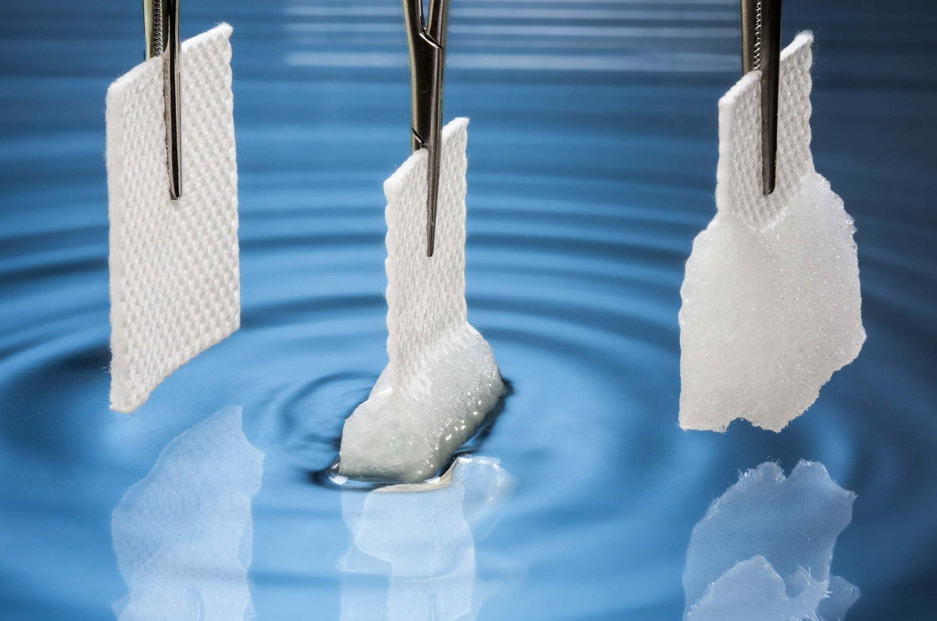Freudenberg now offers an elastic variant of tis superabsorber for modern wound dressings.*

Contacts for media inquiries

Freudenberg Performance Materials Holding SE & Co. KG

Holger Steingraeber, SVP Global Marketing & Communications

Höhnerweg 2-4 / 69469 Weinheim / Germany

Phone +49 6201 7107 007

Holger.Steingraeber@freudenberg-pm.com

www.freudenberg-pm.com

Katrin Böttcher, Manager Global Media Relations

Höhnerweg 2-4 / 69469 Weinheim / Germany

Phone +49 6201 7107 014

Katrin.Boettcher@freudenberg-pm.com

www.freudenberg-pm.com

About Freudenberg Performance Materials

Freudenberg Performance Materials is a leading global supplier of innovative technical textiles for a broad range of markets and applications such as apparel, automotive, building interiors, building materials, healthcare, energy, filter media, shoe and leather goods as well as specialties. In 2021, the company generated sales of more than €1.3 billion, had 33 production sites in 14 countries around the world and had some 5.000 employees. Freudenberg Performance Materials attaches great importance to social and ecological responsibility as the basis for its business success. For more information, please visit [www.freudenberg-pm.com](http://www.freudenberg-pm.com)

The company is a Business Group of Freudenberg Group. In 2021, the Freudenberg Group employed some 50,000 people in around 60 countries worldwide and generated sales of more than €10 billion. For more information, please visit [www.freudenberg.com](https://eur02.safelinks.protection.outlook.com/?url=http%3A%2F%2Fwww.freudenberg.com%2F&data=04%7C01%7CKatrin.Boettcher%40freudenberg-pm.com%7C4e6ece316c5b4cdd06cf08da115fcb53%7Cc7b0778106f341d7b40f5b2de1018509%7C0%7C0%7C637841400374918741%7CUnknown%7CTWFpbGZsb3d8eyJWIjoiMC4wLjAwMDAiLCJQIjoiV2luMzIiLCJBTiI6Ik1haWwiLCJXVCI6Mn0%3D%7C3000&sdata=Ie7Mo0DA5F5RDf5Qsh%2FCTH3acGvKyFOpn9pGGijkN1Y%3D&reserved=0).