**PRESS RELEASE**

**Dr. Andreas Raps named new CEO and Marco Altherr new CFO at Freudenberg Performance Materials effective January 1, 2024**

**Weinheim, November 15, 2023.** **New appointments to the Management Board of Freudenberg Performance Materials come into effect on January 1, 2024: Dr. Andreas Raps succeeds Dr. Frank Heislitz as Chief Executive Officer (CEO), and Marco Altherr takes over from Thomas Herr as Chief Financial Officer (CFO). From January 1, 2024, the Management Board of Freudenberg Performance Materials will therefore consist of: Dr. Andreas Raps (CEO), Marco Altherr (CFO) and John McNabb (CTO). McNabb has been CTO since 2018. Dr. Frank Heislitz and Thomas Herr become members of the Freudenberg Group Board of Management on January 1, 2024.**

“Freudenberg Performance Materials is a leading global manufacturer of innovative technical textiles. I’m honored and excited to further drive key elements of success, such as customer centricity, digitalization and sustainability,” Dr. Andreas Raps said. Dr. Mohsen Sohi, CEO of the Freudenberg Group, added: “With Dr. Andreas Raps and Marco Altherr, two internationally experienced managers are joining the Freudenberg Performance Materials Board of Management. Both have a wealth of expertise and have made outstanding contributions to the development of the Freudenberg Group. Together with John McNabb, they form a strong leadership team.”

**The future CEO**

Dr. Andreas Raps has been a member of the Freudenberg SE Executive Council since 2020 and CEO of EagleBurgmann, a joint venture between the Japanese EKK Group and the Freudenberg Group, since 2016. He previously held several executive management positions at Freudenberg Sealing Technologies from 2004, most recently as CEO of the global Special Sealing Division with 17 manufacturing sites worldwide. Before joining the Freudenberg Group, Raps worked for various management consulting companies in Boston, USA, Munich, Germany, and Zurich, Switzerland. He holds an MBA from the University of Passau. Alongside his job as a consultant, he obtained a PhD with a thesis on strategy implementation in Business Administration.

**The future CFO**

Marco Altherr has been CFO of Vibracoustic SE, a Freudenberg Group company, since 2020. He held various senior management positions at Freudenberg & Co. KG, the technology group’s holding company, from 2015 to 2020, most recently as Head of Corporate Controlling and Accounting. Prior to joining Freudenberg, he served in several management roles at Manroland AG, Heidelberger Druckmaschinen, Boehringer Ingelheim and Arthur Andersen. He holds a degree in business administration specializing in controlling and financing from Lahr University.

**Pictures**

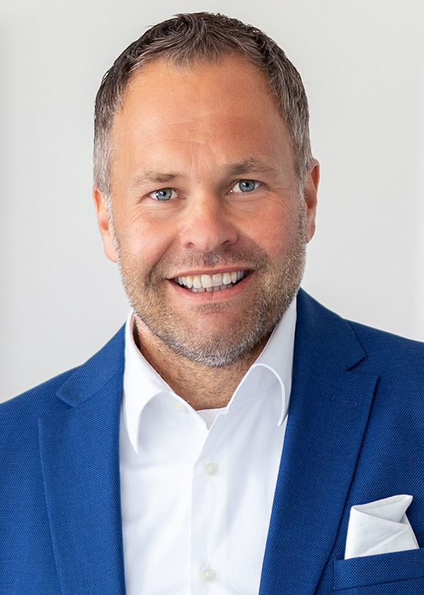

*Dr. Andreas Raps designated CEO Freudenberg Performance Materials*

*©Freudenberg Performance Materials*

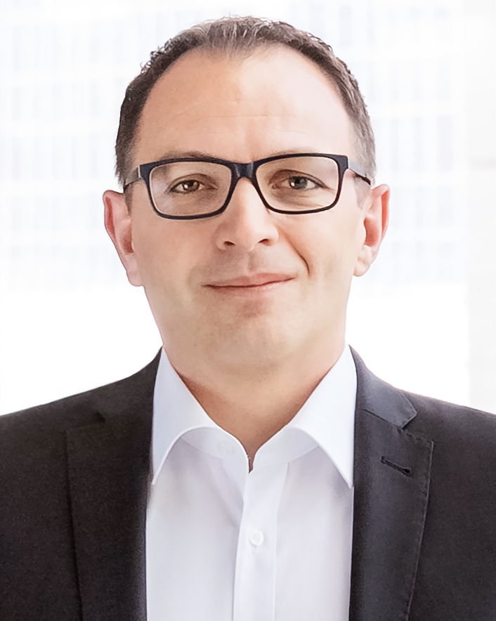

*Dr. Andreas Raps designated CEO FPM*

*©Freudenberg Performance Materials*

Media contacts

Freudenberg Performance Materials Holding GmbH

|  |  |
| --- | --- |
| Holger Steingräber  SVP Global Marketing & Communications  Höhnerweg 2-4, 69469 Weinheim, Germany  +49 6201 7107 007  Holger.Steingraeber@freudenberg-pm.com  [www.freudenberg-pm.com](http://www.freudenberg-pm.com) | Katrin Böttcher  Manager Global Marketing & Communications  Höhnerweg 2-4, 69469 Weinheim, Germany  +49 6201 7107 014  Katrin.Boettcher@freudenberg-pm.com  [www.freudenberg-pm.com](http://www.freudenberg-pm.com) |

About Freudenberg Performance Materials

Freudenberg Performance Materials is a leading global supplier of innovative technical textiles for a broad range of markets and applications such as apparel, automotive, building interiors, building materials, healthcare, energy, filter media, shoe and leather goods as well as specialties. In 2022, the company generated sales of some €1.6 billion, had 32 production sites in 14 countries around the world and had more than 5.000 employees. Freudenberg Performance Materials attaches great importance to social and ecological responsibility as the basis for its business success. For more information, please visit [www.freudenberg-pm.com](https://eur02.safelinks.protection.outlook.com/?url=http%3A%2F%2Fwww.freudenberg-pm.com%2F&data=05%7C01%7CKatrin.Boettcher%40freudenberg-pm.com%7Cb842f96c332449e3846008db463194a9%7Cc7b0778106f341d7b40f5b2de1018509%7C0%7C0%7C638180950979533767%7CUnknown%7CTWFpbGZsb3d8eyJWIjoiMC4wLjAwMDAiLCJQIjoiV2luMzIiLCJBTiI6Ik1haWwiLCJXVCI6Mn0%3D%7C3000%7C%7C%7C&sdata=Z9Qqpb2bKguISzdIflVrbN0g2mD9qRU2HMGh9yoXy6Y%3D&reserved=0)

In 2022, the Freudenberg Group employed more than 51,000 people in around 60 countries worldwide and generated sales of more than €11,7 billion. For more information. please visit [www.freudenberg.com](https://eur02.safelinks.protection.outlook.com/?url=http%3A%2F%2Fwww.freudenberg.com%2F&data=05%7C01%7CKatrin.Boettcher%40freudenberg-pm.com%7Cb842f96c332449e3846008db463194a9%7Cc7b0778106f341d7b40f5b2de1018509%7C0%7C0%7C638180950979533767%7CUnknown%7CTWFpbGZsb3d8eyJWIjoiMC4wLjAwMDAiLCJQIjoiV2luMzIiLCJBTiI6Ik1haWwiLCJXVCI6Mn0%3D%7C3000%7C%7C%7C&sdata=kH5NQGuO0LOpwQ2PIXl2iez%2BBW%2Fx6R23TY23WFjHWQ8%3D&reserved=0).