PRESS RELEASE

Freudenberg to showcase innovative surface veils, flow media and spacers at JEC World 2024 in Paris

Weinheim, February 1, 2024. Freudenberg Performance Materials (Freudenberg) will exhibit a wide range of technical textile solutions for the composites industry at JEC World, the leading international composites show, in Paris, France. This includes surfacing veils for fiber-reinforced plastic (FRP) components and Enka® Solutions flow media and spacers for composites manufacturing. Visitors can meet Freudenberg experts at booth P82.4 of the Baden-Württemberg International booth in Hall 6 from March 5-7, 2024.

Freudenberg addresses the evolving requirements of manufacturers of FRP parts with high-performance nonwovens. To achieve this, the leading supplier of innovative technical textiles uses a variety of technologies such as wetlaid, drylaid and spunbond processes, which enables a wide range of options for the choice of fibers, filaments and compositions. Freudenberg offers a comprehensive portfolio of nonwovens, including glass, PAN, and PET. These materials are specifically engineered for applications such as anti-corrosive coatings in piping and tank construction, UV-resistant facade panels, and various other end products. Surface veils are a crucial component of FRP components, ensuring abrasion resistance, corrosion protection, smooth surfaces, and enhanced mechanical strength. Freudenberg's nonwoven solutions deliver exceptional performance across all these aspects, making them an ideal choice for a wide range of FRP applications.

High-efficiency flow media and spacers for composites manufacturing
Enka® Solutions products are designed for efficient resin infusion and foam injection molding processes. Thanks to their distinctive 3D entangled polymeric filament structures they are exceptionally well-suited as flow media and spacers in composites manufacturing processes.
Enka® Solutions flow media for vacuum-assisted resin transfer molding (VARTM) and resin transfer molding (RTM) processes promote extremely fast and reliable resin distribution ensuring full wet-out of the internal structure, whilst keeping the glass fiber reinforcement nettings and components surface in place. A superior bond, enhanced mechanical properties and even a reduced risk of wrinkling is then achieved.
The Enka® Solutions spacer applied in reaction injection molding processes using foam pushes the reinforcement matting and composite skin against the mold. This allows polymer foam to flow freely through the mold, filling the cavity completely and resulting in faster production processes that ensure reproducible high-quality finished products.

Fotos
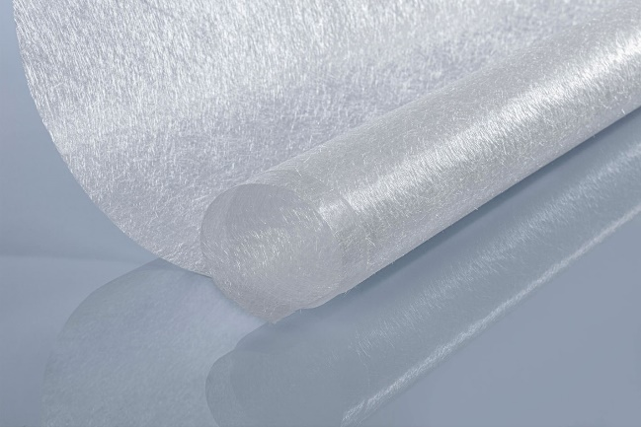  Freudenberg´s glass fiber surfacing veil  Source: ©Freudenberg Performance Materials | 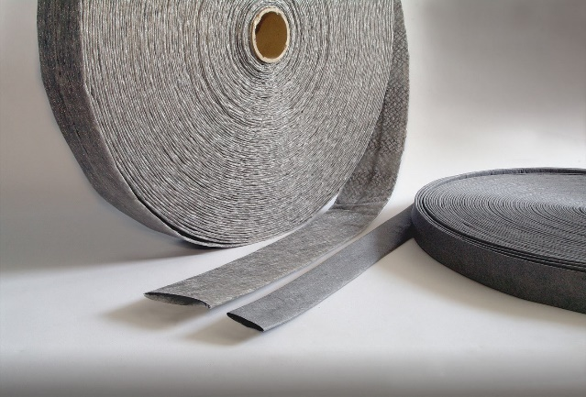  Freudenberg´s EnkaChannel  Source: ©Freudenberg Performance Materials

Contact for media inquiries
Freudenberg Performance Materials Holding SE & Co. KG
Holger Steingraeber, SVP Global Marketing & Communications
Höhnerweg 2-4 / 69469 Weinheim / Germany
Phone +49 6201 7107 007
Holger.Steingraeber@freudenberg-pm.com
www.freudenberg-pm.com

Katrin Böttcher, Manager Global Media Relations
Höhnerweg 2-4 / 69469 Weinheim / Germany
Phone +49 6201 7107 014
Katrin.Boettcher@freudenberg-pm.com
www.freudenberg-pm.com

About Freudenberg Performance Materials
Freudenberg Performance Materials is a leading global supplier of innovative technical textiles for a broad range of markets and applications such as apparel, automotive, building interiors, building materials, healthcare, energy, filter media, shoe and leather goods as well as specialties. In 2022, the company generated sales of some €1.6 billion, had 32 production sites in 14 countries around the world and had more than 5.000 employees. Freudenberg Performance Materials attaches great importance to social and ecological responsibility as the basis for its business success. For more information, please visit www.freudenberg-pm.com
In 2022, the Freudenberg Group employed more than 51,000 people in around 60 countries worldwide and generated sales of more than €11,7 billion. For more information, please visit www.freudenberg.com.

