PRESS RELEASE

Freudenberg Performance Materials Apparel inaugurates
state-of-the-art thermal insulation factory in Vietnam

Weinheim, Germany, July 23, 2024. Freudenberg Performance Materials Apparel (Freudenberg Apparel) is proud to announce the production opening of its state-of-the-art thermal insulation factory located in Long Thanh District, Vietnam. This facility specializes in the production of comfortemp®, Freudenberg’s renowned high-performance thermal insulation material, designed to elevate fashion and sportswear apparel.

"With the opening of our first production site in Vietnam we are set to meet the thriving demand in the Southeast Asian and South Asian garment manufacturing industries, reinforcing both our presence in and commitment to the region," stated John McNabb, Chief Technology Officer at Freudenberg Performance Materials. "By localizing the production of our thermal insulation materials in Vietnam, we are not only reducing lead times for our customers but also streamlining the supply chain, ensuring we continue to deliver exceptional value for customers." The Vietnamese facility is equipped to produce sustainable thermal insulations, providing customers with options that align with their sustainable garment production initiatives and goals.

This additional new factory extends Freudenberg Apparel's thermal insulation production across key Asian markets, including the Chinese mainland and South Korea. It also significantly strengthens Freudenberg Apparel’s global production capabilities and supply network. This expansion will bolster the company's competitive edge in Asia and reaffirms its ongoing dedication to innovation and evolution within the apparel industry.

Photo:
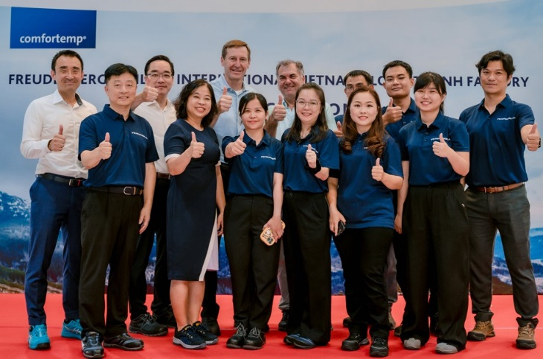
Some of Freudenberg Performance Materials Apparel´s Vietnam team members with top management during the inauguration. Back row from left to right: Masahiro Nakano, VP of Finance and Controlling, Global Sourcing and Digitalization Freudenberg Performance Materials Apparel, Jonathan Oh, SVP Freudenberg Performance Materials Apparel, John McNabb, CTO Freudenberg Performance Materials

Contact for media inquiries
Freudenberg Performance Materials Holding SE & Co. KG
Holger Steingraeber, SVP Global Marketing & Communications
Höhnerweg 2-4 / 69469 Weinheim / Germany
Phone +49 6201 7107 007
Holger.Steingraeber@freudenberg-pm.com
www.freudenberg-pm.com

Katrin Böttcher, Manager Global Media Relations
Höhnerweg 2-4 / 69469 Weinheim / Germany
Phone +49 6201 7107 014
Katrin.Boettcher@freudenberg-pm.com
www.freudenberg-pm.com

About Freudenberg Performance Materials
Freudenberg Performance Materials is a leading global supplier of innovative technical textiles for a broad range of markets and applications such as apparel, automotive, building interiors, building materials, healthcare, energy, filter media, shoe and leather goods as well as specialties. In 2023, the company generated sales of more than €1.4 billion, had 32 production sites in 14 countries around the world and had more than 5.000 employees. Freudenberg Performance Materials attaches great importance to social and ecological responsibility as the basis for its business success. For more information, please visit www.freudenberg-pm.com.
In 2023, the Freudenberg Group employed more than 52,000 people in around 60 countries worldwide and generated sales of some €11.9 billion. For more information, please visit www.freudenberg.com.

