PRESS RELEASE

Freudenberg Apparel launches complete RCY 99xx shirt interlining series made of recycled polyester.

Weinheim, July 2, 2024. Freudenberg Performance Materials Apparel (Freudenberg Apparel) launches the global the complete RCY 99xx series recycled polyester (rPET) shirt interlinings. This innovative product line serves as a sustainable counterpart to Freudenberg's renowned 95xx series, which has been a staple in the industry for over twenty years.

A heritage reimagined: From 95xx to RCY 99xx
The 95xx series, celebrated for its unique bi-elastic properties, has earned its place as one of Freudenberg Apparel's most sought-after shirt interlining ranges worldwide. Cherished by customers across the globe, the 95xx series has consistently delivered on quality and performance.

Sustainability meets innovation: Introducing the RCY 99xx Series
Now, taking a leap towards sustainability, Freudenberg Apparel introduces the complete RCY 99xx series. Crafted from rPET, these bi-elastic interlinings are designed to complement an array of contemporary fabrics, including pure cotton, T/C, flannel, oxford, cotton & linen blends, seersucker, jersey, and all types of stretch knits. The RCY 99xx series not only preserves the natural hand-feel, texture, and shape of these fabrics but also infuses a fresh creative dimension into shirt design.
The RCY 99xx series boasts an impressive weight range of 30-150 g/m2, offering versatility for a diverse spectrum of shirt styles, from men’s casual shirts and women's blouses to polo shirts, sports shirts, and even denim shirts. This adaptability ensures that designers and manufacturers have the flexibility to meet the evolving demands of the market while upholding sustainability principles.
House of Sustainability - Responsible products every season
Designed to support customers to achieve their sustainability mission, Freudenberg's Apparel House of Sustainability is at the forefront of driving sustainable innovation and brings forth latest solutions in every garment manufacturing season. The RCY 99xx series, emerging from Recycled General Interlinings category, exemplifies Freudenberg Apparel's unwavering pledge to innovation with a sustainable impact.

Fotos
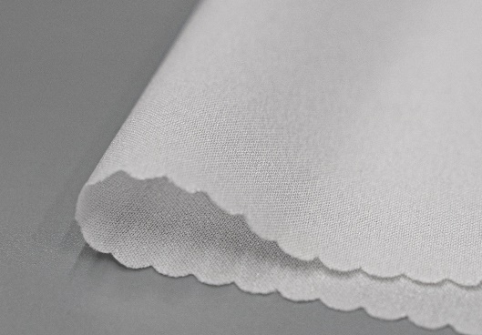
Freudenberg Apparel´s rPET interlining solution 99xx for shirt, blouse or polo shirt.
Source: ©Freudenberg Performance Materials

Contact for media inquiries
Freudenberg Performance Materials Holding SE & Co. KG
Holger Steingraeber, SVP Global Marketing & Communications
Höhnerweg 2-4 / 69469 Weinheim / Germany
Phone +49 6201 7107 007
Holger.Steingraeber@freudenberg-pm.com
www.freudenberg-pm.com

Katrin Böttcher, Manager Global Media Relations
Höhnerweg 2-4 / 69469 Weinheim / Germany
Phone +49 6201 7107 014
Katrin.Boettcher@freudenberg-pm.com
www.freudenberg-pm.com

About Freudenberg Performance Materials
Freudenberg Performance Materials is a leading global supplier of innovative technical textiles for a broad range of markets and applications such as apparel, automotive, building interiors, building materials, healthcare, energy, filter media, shoe, and leather goods as well as specialties. In 2023, the company generated sales of more than €1.4 billion, had 32 production sites in 14 countries around the world and had more than 5.000 employees. Freudenberg Performance Materials attaches great importance to social and ecological responsibility as the basis for its business success. For more information, please visit www.freudenberg-pm.com.

In 2023, the Freudenberg Group employed more than 52,000 people in around 60 countries worldwide and generated sales of some €11,9 billion. For more information, please visit www.freudenberg.com.

