PRESS RELEASE

Apparel Sourcing Week 2024: Freudenberg Apparel to showcase sustainable innovations in fashion, sportswear, and shirt segments

Weinheim, Germany, August 21, 2024. Freudenberg Performance Materials Apparel (Freudenberg Apparel) will be presenting its sustainable interlinings, canvas, thermal insulations, and linings from the House of Sustainability specifically tailored for fashion, sportswear, and shirt segments at the Apparel Sourcing Week 2024. The event will take place from August 28-29 in Bangalore and is pivotal for the fashion industry, reflecting the dynamic apparel sourcing landscape in India. Freudenberg Apparel will be welcoming visitors to booth B10.

Innovative interlinings for shirt and menswear
Freudenberg Apparel will introduce the latest innovations in shirt interlining technology with the RCY 99xx series, offering weights from 30 g/m² to 155 g/m². This series is designed for contemporary fabrics that maintain the natural hand feel, texture, and shape, while also adding a creative edge to shirt design. Additionally, the RCY 39xx series, weighing from 70 g/m² to 167 g/m², will be highlighted for its cotton-like hand feel, comparable to traditional cotton interlining. Made with rPET, it ensures durability and low-temperature fusing without visible impurities.

In the fashion segment, the MTW series of bi-elastic twill interlinings will be presented, noted for their strong bond, resilience, and high shape retention even after multiple washes. These features make them ideal for washable jackets and contribute to the durability and longevity of garments. The GBE series will demonstrate its superior bonding and elasticity, perfect for hydro-expansion fabrics like CV and spandex, offering up to 30% stretch adaptability.

Active and outdoor sportswear exhibits
Freudenberg Apparel will showcase a comprehensive range of interlinings from its Active Range, designed for active sportswear. The highlights include rTPE base content interlinings, available in a weight range of 40-90 g/m², suitable for fabrics from lightweight to heavy, as found in leggings, sports bras, and casual wear. Freudenberg Apparel will also display film bonding solutions for seamless applications in bras, briefs, and tees, which emphasize strong shear bonds that eliminate the need for stitching. In the outdoor sportswear segment, a variety of sustainable thermal insulations and linings will be on show, including rPET, biodegradable thermal insulations, and rPET linings, all reflecting Freudenberg´s commitment to sustainability.

Freudenberg Apparel's commitment to South Asia
The company's participation in the trade show underscores its dedication to the Indian market and the growing apparel manufacturing sector in South Asia. Freudenberg Apparel's ongoing investment in expanding production capabilities in India after 26 successful years signifies the company's commitment to better meet customer demands. New facilities will increase production capacity and enable further diversification in product offerings, with initial projects already underway and additional expansion plans in development.

Photos:
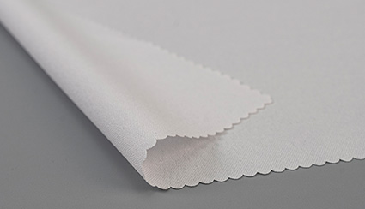
RCY 39xx Series of Cotton-like Shirt Interlinings
Source: ©Freudenberg Performance Materials
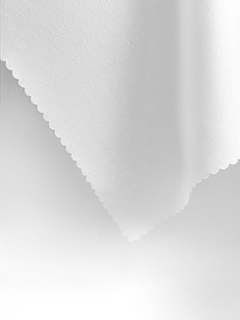
GBE Series of Interlinings for Hydro-expansion Fabrics
Source: ©Freudenberg Performance Materials

Contact for media inquiries

Freudenberg Performance Materials Holding GmbH
Holger Steingraeber  SVP Global Marketing & Communications  Höhnerweg 2-4 / 69469 Weinheim / Germany  Phone +49 6201 7107 007  Holger.Steingraeber@freudenberg-pm.com  www.freudenberg-pm.com | Katrin Böttcher  Manager Global Media Relations  Höhnerweg 2-4 / 69469 Weinheim / Deutschland  Telefon +49 6201 7107 014  Katrin.Boettcher@freudenberg-pm.com  www.freudenberg-pm.com

About Freudenberg Performance Materials
Freudenberg Performance Materials is a leading global supplier of innovative technical textiles for a broad range of markets and applications such as apparel, automotive, building interiors, building materials, healthcare, energy, filter media, shoe and leather goods as well as specialties. In 2023, the company generated sales of more than €1.4 billion, had 32 production sites in 14 countries around the world and had more than 5,000 employees. Freudenberg Performance Materials attaches great importance to social and ecological responsibility as the basis for its business success. For more information, please visit www.freudenberg-pm.com.
In 2023, the Freudenberg Group employed more than 52,000 people in around 60 countries worldwide and generated sales of some €11.9 billion. For more information, please visit www.freudenberg.com.

