**PRESS RELEASE**

**Fachpack 2024: Freudenberg will showcase sustainable innovations for surface protection, food storage and humidity management applications**

**Weinheim, Germany, August 20, 2024. Freudenberg Performance Materials (Freudenberg) will present packaging solutions with various sustainability benefits at Fachpack 2024 in Nuremberg, Germany, from September 24-26. The range of exhibited products includes Evolon® microfilament textiles for reusable technical packaging of sensitive industrial parts, bio-based nonwoven materials for desiccant bags, and Evolon® The Food Bag – an ideal solution for food preservation. The Freudenberg team at Stand 522 in Hall 4A is looking forward to welcoming visitors to the trade fair.**

Freudenberg’s innovative Evolon® technical packaging product line will emphasize the company’s commitment to sustainability. Evolon® offers enhanced surface protection for various kinds of sensitive industrial parts, including molded plastics and painted components. It is notable for its durability and high recycled PET content. The microfilament fabric serves as an eco-friendly alternative to single-use packaging, particularly in the transportation of sensitive industrial goods such as automotive parts. The use of Evolon® not only bolsters operational efficiency but also contributes to resource conservation. Evolon®'s advanced protective qualities reduce damage during transport and lower the rejection rate.

Additionally, Evolon® ESD (electro-static discharge) materials address the need for specialized packaging of sensitive electronic components by providing customizable permanent electro-static discharge protection in additional to excellent surface protection.

**Evolon® The Food Bag – goodbye to food waste**

Freudenberg will also be exhibiting an innovative packaging product for food preservation in the home. Evolon® The Food Bag extends the shelf life of vegetables, fruits and bread by providing excellent moisture and climate management. The innovative bag was a finalist in the 2020 *Zu gut für die Tonne!* prize (“Too Good For The Bin”), part of the National Strategy for Food Waste Reduction launched by Germany’s Federal Ministry of Food and Agriculture (BMEL).

**Sustainable nonwoven materials for desiccant bags**

A further highlight at Fachpack 2024 will be nonwoven materials for manufacturing desiccant bags. In addition to conventional fully synthetic materials, Freudenberg’s product range includes sustainable bio-based wetlaid nonwovens which are binder-free and industrially compostable.

**Photos:**

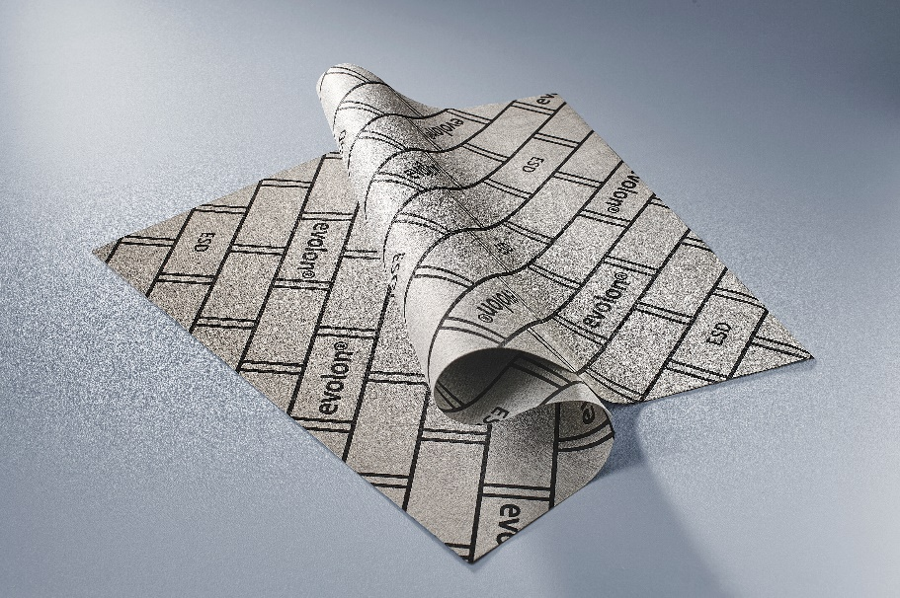

Evolon® ESD technical packaging

*Source: ©Freudenberg Performance Materials*

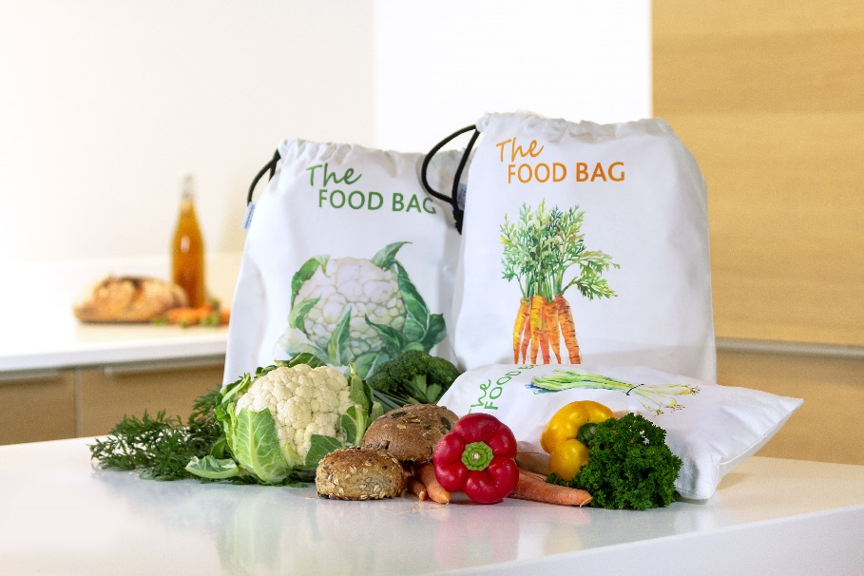

Evolon® The Food Bag

*Source: ©Freudenberg Performance Materials*

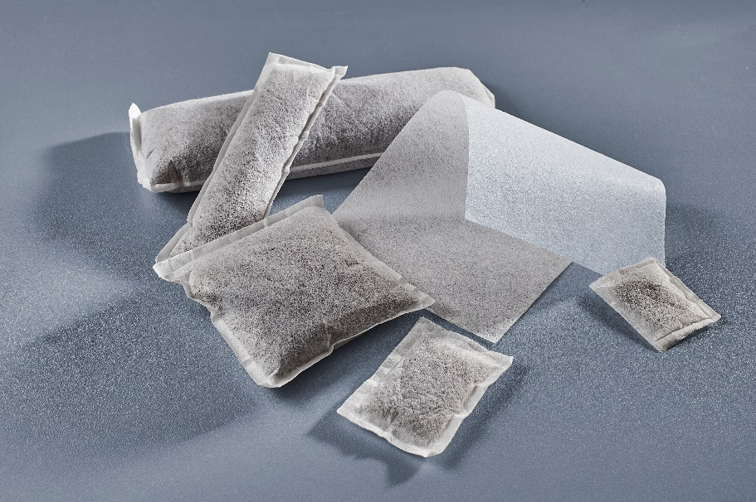

Desiccant bags made from Freudenberg bio-based wetlaid nonwovens

*Source: ©Freudenberg Performance Materials*

Contact for media inquiries

Freudenberg Performance Materials Holding SE & Co. KG

|  |  |
| --- | --- |
| Holger Steingraeber  SVP Global Marketing & Communications  Höhnerweg 2-4 / 69469 Weinheim / Germany  Phone +49 6201 7107 007  Holger.Steingraeber@freudenberg-pm.com  www.freudenberg-pm.com | Katrin Böttcher  Manager Global Media Relations  Höhnerweg 2-4 / 69469 Weinheim / Germany  Phone +49 6201 7107 014  Katrin.Boettcher@freudenberg-pm.com  www.freudenberg-pm.com |

About Freudenberg Performance Materials

Freudenberg Performance Materials is a leading global supplier of innovative technical textiles for a broad range of markets and applications such as apparel, automotive, building interiors, building materials, healthcare, energy, filter media, shoe and leather goods as well as specialties. In 2023, the company generated sales of more than €1.4 billion, had 32 production sites in 14 countries around the world and had more than 5,000 employees. Freudenberg Performance Materials attaches great importance to social and ecological responsibility as the basis for its business success. For more information, please visit [www.freudenberg-pm.com](http://www.freudenberg-pm.com)

In 2023, the Freudenberg Group employed more than 52,000 people in around 60 countries worldwide and generated sales of some €11.9 billion. For more information, please visit [www.freudenberg.com](http://www.freudenberg.com)