**PRESS RELEASE**

**Freudenberg Apparel launches Film Bonding series: A new dimension in sew-free garments**

**Weinheim, Germany, September 12, 2024. Freudenberg Performance Materials Apparel (Freudenberg Apparel) is pleased to introduce the innovative Film Bonding series. This new line of solutions is expertly designed for advanced sew-free bonding applications, enhancing the manufacturing process with modern efficiency and precision. In conjunction with this launch, Freudenberg Apparel is expanding its Net Bonding and Dot Bonding series, further broadening its range of seamless adhesive solutions to cater to the specific demands of the Stretch Active, Intimate, and Athleisure wear segments.**

**Introducing the Film Bonding series and the expanded Net Bonding series**

Freudenberg Apparel's Film Bonding series features a film structure with a high-quality adhesive, delivering robust shear bond and recovery. This enables garments to conform to the body's shape while retaining their shape and integrity after stretching, significantly improving durability and wearer comfort. By eliminating bulky seams, the Film Bonding series also provides a clean, smooth finish to fabric surfaces.

Available in tape form, Freudenberg Apparel's Film Bonding solutions accommodate a wide range of weight requirements from 90 to 220 g/m², including thin options under 80µm. The series offers an array of TPE and TPU variants with varying softness levels from medium to very soft, reducing reliance on traditional stitching and making them ideal for various applications, including stitch-free seam bonding on briefs, bras, vests, and leggings.

Complementing the Film Bonding series, Freudenberg has introduced an innovative oval net structure to its TPE polymer adhesive Net Bonding series. This new structure, in addition to the existing Diamond and Hexagon patterns, offers a diverse selection of net structures suitable for a wide array of applications. The expanded weight range of 50-240 g/m² for the Net Bonding solutions provides versatility for creating breathable, elastic, and well-controlled garments in leggings, sports bras, and intimate apparel.

**Freudenberg: Pioneering innovation in bonding technology**

Freudenberg Apparel's commitment to innovation is driving the evolution of traditional bonding methods. By harnessing the power of the TPE polymer in its bonding solutions, the company has achieved an optimal blend of softness and elasticity. These advanced TPE polymer bonding solutions are designed to operate at lower melting temperatures, ensuring strong bond strength without compromising fabric integrity.

For further insights into the features and benefits of the Film Bonding series, Net Bonding series, and Dot Bonding solutions, visit our website at [FREUDENBERG ACTIVERANGE-Film Bonding Solutions (freudenberg-pm.com).](https://eur02.safelinks.protection.outlook.com/?url=https%3A%2F%2Factiverange.freudenberg-pm.com%2Ffilm_bonding_solutions&data=05%7C02%7CAnnalena.Wahlig%40freudenberg-pm.com%7Cc1af425af8eb4b403f0c08dcd1fd1a3b%7Cc7b0778106f341d7b40f5b2de1018509%7C0%7C0%7C638616132193493053%7CUnknown%7CTWFpbGZsb3d8eyJWIjoiMC4wLjAwMDAiLCJQIjoiV2luMzIiLCJBTiI6Ik1haWwiLCJXVCI6Mn0%3D%7C0%7C%7C%7C&sdata=DQzTy9ccZPxGfsA4kwselvUnF5cKDtvxajfGmQcef4o%3D&reserved=0)

**Photos:**

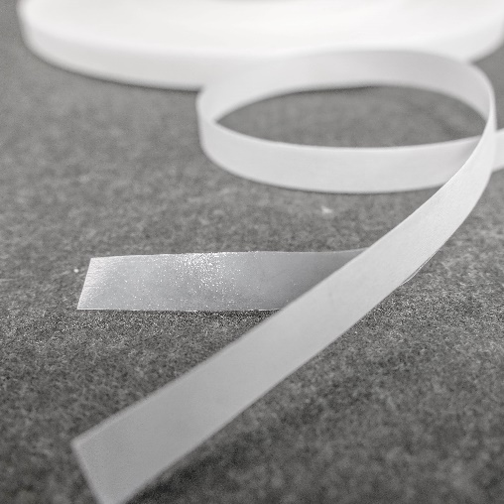

Freudenberg Apparel´s Film Bonding series product in tape form.

*Source: ©Freudenberg Performance Materials*



Freudenberg Apparel´s Net Bonding series product in oval structure.

*Source: ©Freudenberg Performance Materials*

Contact for media inquiries

Freudenberg Performance Materials Holding GmbH

|  |  |
| --- | --- |
| Holger Steingraeber  SVP Global Marketing & Communications  Höhnerweg 2-4 / 69469 Weinheim / Germany  Phone +49 6201 7107 007  Holger.Steingraeber@freudenberg-pm.com  www.freudenberg-pm.com | Katrin Böttcher  Manager Global Media Relations  Höhnerweg 2-4 / 69469 Weinheim / Germany  Phone +49 6201 7107 014  Katrin.Boettcher@freudenberg-pm.com  www.freudenberg-pm.com |

About Freudenberg Performance Materials

Freudenberg Performance Materials is a leading global supplier of innovative technical textiles for a broad range of markets and applications such as apparel, automotive, building interiors, building materials, healthcare, energy, filter media, shoe and leather goods as well as specialties. In 2023, the company generated sales of more than €1.4 billion, had 32 production sites in 14 countries around the world and had more than 5,000 employees. Freudenberg Performance Materials attaches great importance to social and ecological responsibility as the basis for its business success. For more information, please visit www.freudenberg-pm.com.

In 2023, the Freudenberg Group employed more than 52,000 people in around 60 countries worldwide and generated sales of some €11.9 billion. For more information, please visit www.freudenberg.com.