PRESS RELEASE

New Filtura® website: Explore innovative filtration media from Freudenberg Performance Materials

Weinheim, Germany, October 29, 2024. Freudenberg Performance Materials is constantly driving innovation. The new website for its Filtura® filter media brand underscores this ambition. The new platform offers a comprehensive and intuitive experience, allowing customers and partners to explore Filtura®’s innovative filtration solutions for the air, liquid and automotive markets.

The new website presents Freudenberg's broad product portfolio and its industry expertise together with innovative technologies, thus helping customers in various industries to drive the efficiency, sustainability, and performance of their filtration systems.

Find out more about applications, solutions, and technologies
The "Markets" menu item provides insights into Filtura®'s tailor-made solutions for three extremely demanding application areas: air filtration, liquid filtration and filtration solutions for the automotive industry. This is where you can discover why the Filtura® brand stands for high performance, durability and energy efficiency.

The "Solutions" menu presents the wide range of Filtura® products and services. These solutions are designed to meet specific filtration needs, from high-performance functionalized filtration media to advanced support components and synthetic filter frames that enhance durability and functionality.

The “Technologies” menu focuses on the advanced materials that can be customized to meet individual performance specifications. This section gives insights into filtration materials such as spunbond nonwovens, needle-punched nonwovens, 3D mats, meltblown filter materials, drylaid, wetlaid and composite technology capabilities.

Click here for the new website: www.filtura.com

Photo:
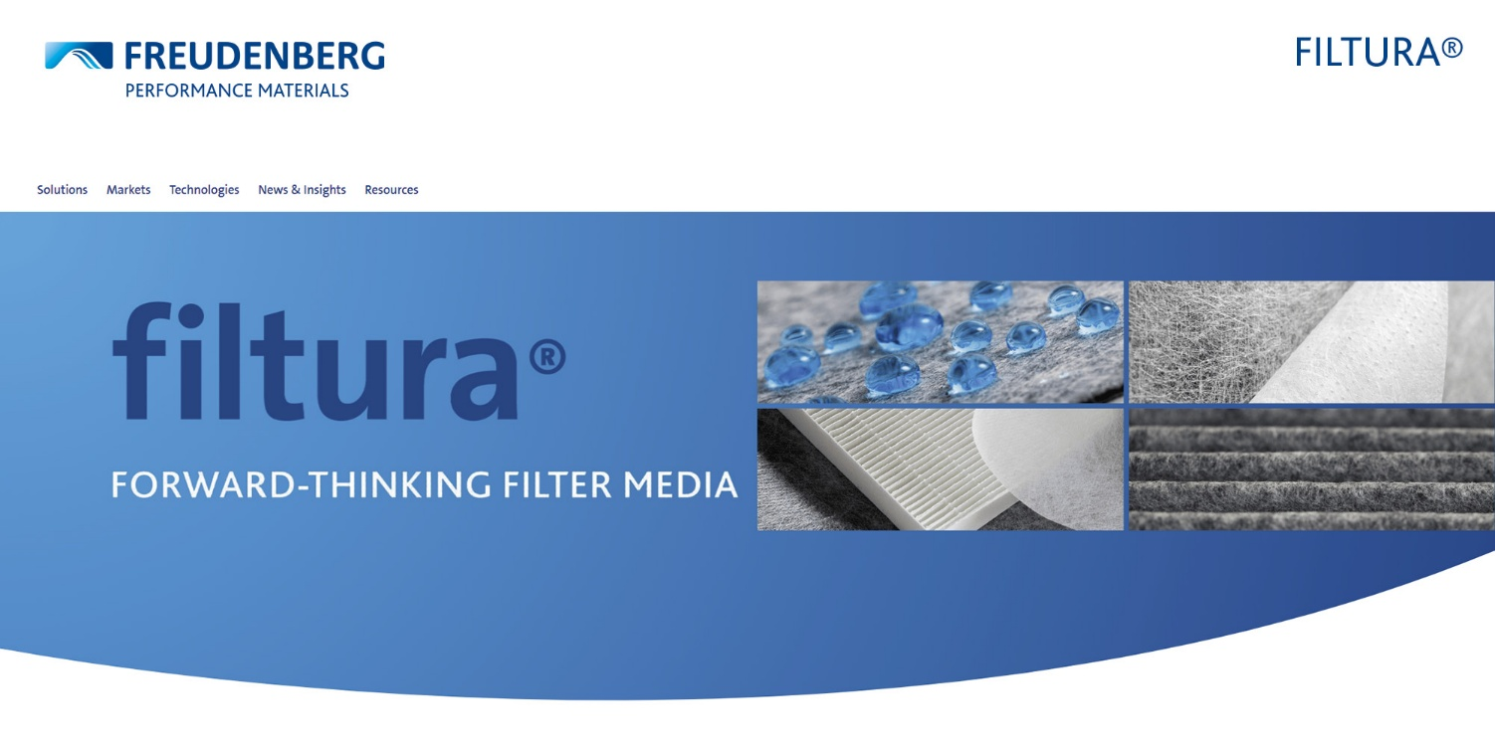

Starting page of the new Filtura® website.
Source: ©Freudenberg Performance Materials

Contact for media enquiries

Freudenberg Performance Materials Holding GmbH
Holger Steingraeber  SVP Global Marketing & Communications  Höhnerweg 2-4 / 69469 Weinheim / Deutschland  Telefon +49 6201 7107 007  Holger.Steingraeber@freudenberg-pm.com  www.freudenberg-pm.com | Katrin Böttcher  Manager Global Media Relations  Höhnerweg 2-4 / 69469 Weinheim / Deutschland  Telefon +49 6201 7107 014  Katrin.Boettcher@freudenberg-pm.com  www.freudenberg-pm.com

About Freudenberg Performance Materials
Freudenberg Performance Materials is a leading global supplier of innovative technical textiles for a broad range of markets and applications such as apparel, automotive, building interiors, building materials, healthcare, energy, filter media, shoe and leather goods as well as specialties. In 2023, the company generated sales of more than €1.4 billion, had 32 production sites in 14 countries around the world and had more than 5,000 employees. Freudenberg Performance Materials attaches great importance to social and ecological responsibility as the basis for its business success. For more information, please visit www.freudenberg-pm.com.
In 2023, the Freudenberg Group employed more than 52,000 people in around 60 countries worldwide and generated sales of some €11.9 billion. For more information, please visit www.freudenberg.com.

