PRESS RELEASE

Freudenberg Performance Materials invests in technology for bioactive nonwovens

Weinheim, November 26, 2024. The healthcare segment is an important pillar in the portfolio of Freudenberg Performance Materials (Freudenberg). The healthcare range includes components for modern and traditional wound treatment, elastic backing materials, products for incontinence management and filters for stoma care. The leading global supplier of technical textiles is now expanding the scope of its technologies for the healthcare market to include bioresorbable nonwovens. These nonwovens will initially be used in the management of surgical hemostasis.

“Expanding our range of technologies to include bioresorbable nonwovens for use in managing surgical hemostasis brings our customers several benefits: the innovative solution is more effective than existing options, so it reduces costs and can, in some cases, even save lives,” said Dr. Henk R. Randau, SVP of the global Healthcare Division at Freudenberg Performance Materials. The technology in question is used in the manufacture of nonwovens made from bioresorbable raw materials that are resorbed by the body. Freudenberg has installed specially-designed equipment for this purpose. Looking to the future, the company plans to collaborate with partners to offer a broad range of solutions for bioactive wound healing, drug release and regenerative medicine based on this technology.

Photo:
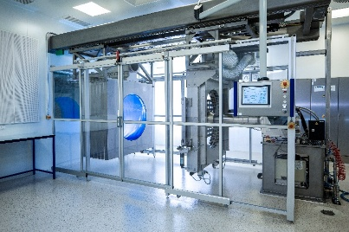
The patented technology is installed in an ISO 8 cleanroom.
Source: ©Freudenberg Performance Materials

Contacts for media inquiries

Freudenberg Performance Materials Holding SE & Co. KG
Holger Steingraeber  SVP Global Marketing & Communications  Höhnerweg 2-4 / 69469 Weinheim / Germany  Phone +49 6201 7107 007  Holger.Steingraeber@freudenberg-pm.com  www.freudenberg-pm.com | Katrin Böttcher  Manager Global Media Relations  Höhnerweg 2-4 / 69469 Weinheim / Germany  Phone +49 6201 7107 014  Katrin.Boettcher@freudenberg-pm.com  www.freudenberg-pm.com

About Freudenberg Performance Materials
Freudenberg Performance Materials is a leading global supplier of innovative technical textiles for a broad range of markets and applications such as apparel, automotive, building interiors, building materials, healthcare, energy, filter media, shoe and leather goods as well as specialties. In 2023, the company generated sales of more than €1.4 billion, had 32 production sites in 14 countries around the world and had more than 5,000 employees. Freudenberg Performance Materials attaches great importance to social and ecological responsibility as the basis for its business success. For more information, please visit www.freudenberg-pm.com
In 2023, the Freudenberg Group employed more than 52,000 people in around 60 countries worldwide and generated sales of some €11.9 billion. For more information, please visit www.freudenberg.com

