**PRESS RELEASE**

**Freudenberg to introduce sustainable innovations for shoe and leather goods at Inspiramais trade fair in Brazil**

**Weinheim, December 5, 2024.** **Freudenberg Performance Materials (Freudenberg) will present its full range of high- performance materials for footwear at Inspiramais on January 21st and 22nd, 2025 in Porto Alegre, Brazil. The global leading manufacturer of performance materials will highlight its latest technical and sustainable innovations tailored for the shoe industry, including microfibers, counterliners, liners, interlinings, reinforcements, insoles, and membranes. At Inspiramais, designers and footwear professionals can meet with Brazil-based Freudenberg experts to support them design and develop products in line with the industry's evolving demands for performance and environmental responsibility.**

Freudenberg’s presentation at the event underscores its commitment to innovation and sustainability within the industry. In line with its sustainability goals, Freudenberg has increased the proportion of products in its portfolio that incorporate recycled content and employ solvent-free and binder-free manufacturing processes. The company's efforts are exemplified by its range of vamp liners, reinforcements, and strobel insoles, which contain between 35% to 100% recycled material. The new insoles and reinforcements for sports shoes have recycled fiber content and provide high tensile and tear resistance at the same time.

**Vegan suede**

Additionally, Freudenberg is introducing a solvent-free vegan suede material, crafted from microfiber nonwovens, which offers both breathability and versatility in dyeing—a suitable choice for upper and facing in casual and athletic shoes.

**Innovations for safety shoes and others**

Freudenberg's advancements also extend to the realm of safety footwear, with the introduction of specialized insoles that are resistant to perforation and suitable for PU injection, as well as electrically conductive. Moreover, the company has developed breathable waterproof membranes that can be integrated into liners and interliners, enhancing both comfort and protection for safety shoes, boots, and waterproof footwear.

The company's new range of high performance counterliners is another highlight, designed to cater to a diverse array of footwear categories, including women's, men's, children's, safety shoes, boots, and athletic shoes. These counterliners are distinguished by their breathability, color variety, and superior abrasion resistance.

Photos:

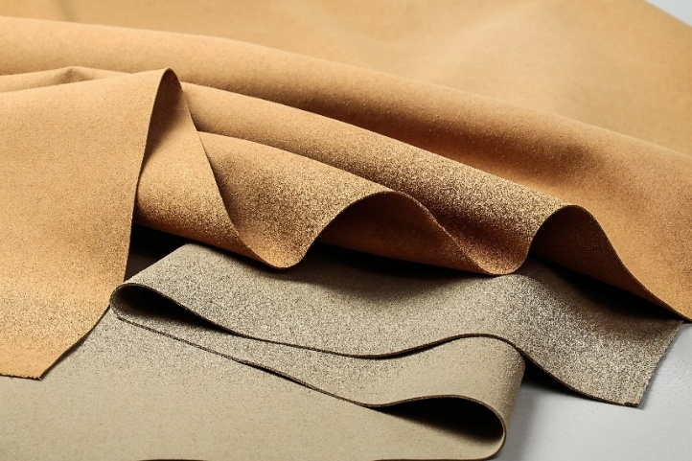

Freudenberg’s vegan suede made from microfiber nonwoven

**Source: ©Freudenberg Performance Materials**

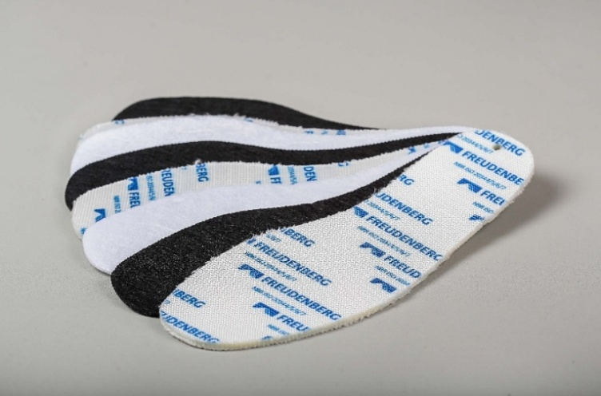

Freudenberg’s special insoles for safety shoes

**Source: ©Freudenberg Performance Materials**

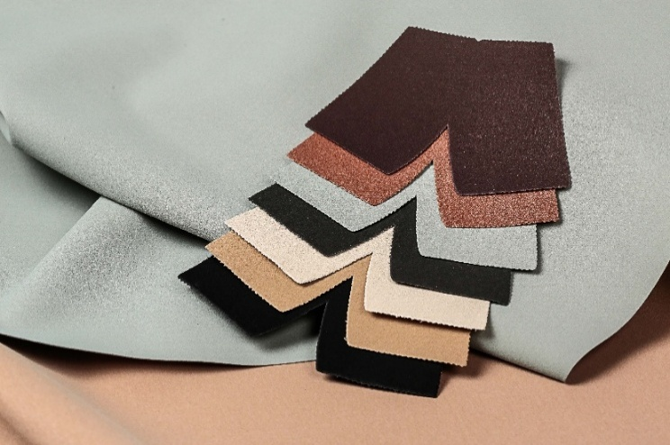

Freudenberg’s high performance counterliners

**Source: ©Freudenberg Performance Materials**

Contact for media inquiries

Freudenberg Performance Materials Holding GmbH

|  |  |
| --- | --- |
| Holger Steingraeber  SVP Global Marketing & Communications  Höhnerweg 2-4 / 69469 Weinheim / Germany  Phone +49 6201 7107 007  Holger.Steingraeber@freudenberg-pm.com  www.freudenberg-pm.com | Katrin Böttcher  Manager Global Media Relations  Höhnerweg 2-4 / 69469 Weinheim / Germany  Phone +49 6201 7107 014  Katrin.Boettcher@freudenberg-pm.com  www.freudenberg-pm.com |

About Freudenberg Performance Materials

Freudenberg Performance Materials is a leading global supplier of innovative technical textiles for a broad range of markets and applications such as apparel, automotive, building interiors, building materials, healthcare, energy, filter media, shoe and leather goods as well as specialties. In 2023, the company generated sales of more than €1.4 billion, had 32 production sites in 14 countries around the world and had more than 5.000 employees. Freudenberg Performance Materials attaches great importance to social and ecological responsibility as the basis for its business success. For more information, please visit [www.freudenberg-pm.com](http://www.freudenberg-pm.com)

In 2023, the Freudenberg Group employed more than 52,000 people in around 60 countries worldwide and generated sales of some €11,9 billion. For more information, please visit [www.freudenberg.com](http://www.freudenberg.com)