PRESS RELEASE

Freudenberg to showcase a wide range of products and nonwoven technical capabilities at JEC World 2025 in Paris

Weinheim, January 30, 2025. Freudenberg Performance Materials (Freudenberg) will be showcasing its high-performance textile and nonwoven solutions for the composites industry at JEC World, the leading international composites show, in Paris, France. These include Enka®Solutions flow media and spacers for composites manufacturing and surfacing veils. Freudenberg experts will welcome visitors to booth P82.5 of the Baden-Württemberg International joint stand in Hall 6 from March 4-6, 2025.

Composite manufacturers will have the opportunity to discuss solutions for optimizing resin infusion and foam injection molding processes with the experts, focusing on Enka®’s unique 3D polymeric filament structures used in Enka®Solutions flow media and spacers. With this technology, manufacturers benefit from a marked improvement in both quality and efficiency, ensuring their products meet the highest standards.

In vacuum-assisted resin transfer molding (VARTM) and resin transfer molding (RTM) processes, composites manufactured using Enka®Solutions flow media have a superior bond and enhanced mechanical properties, which significantly decreases the risk of wrinkling and defects in the final products. Enka®Solutions flow media ensure rapid and reliable resin distribution. This guarantees full wet-out of the internal structure whilst keeping glass fiber reinforcement nettings and component surfaces precisely in place.

Freudenberg will also be presenting Enka®Solutions spacers, which contribute to faster production cycles and reproducible high-quality finished products.

Nonwoven surfacing veils for anti-corrosive coatings in piping and tank construction, UV-resistant facade panels, and other FRP end products.

Freudenberg’s surfacing veils are an essential part of FRP components and provide abrasion resistance, corrosion protection, smooth surfaces, and enhanced mechanical strength. As one of the world’s leading nonwoven manufacturers, Freudenberg’ portfolio of technologies is well suited to meeting the different needs of FRP part manufacturers. At JEC, the company’s experts will highlight the wide variety of technical capabilities for combining glass, PAN, and PET, in the shape of fibers or filaments, using their unique nonwoven expertise in wetlaid, drylaid, and spunbond processes.

Photos:
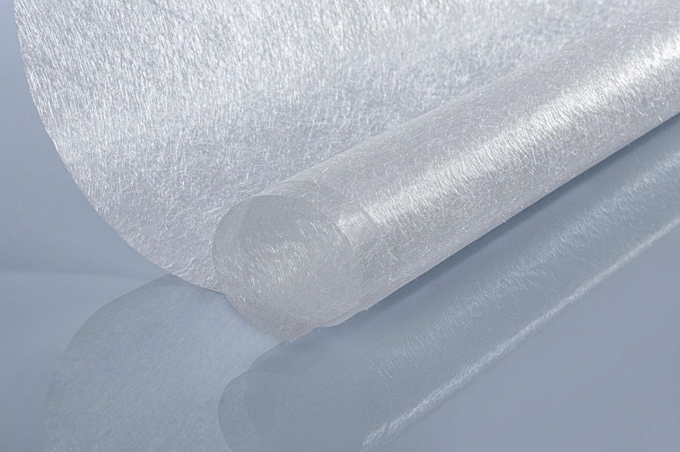
Glass fiber surfacing veil.
Source: ©Freudenberg Performance Materials

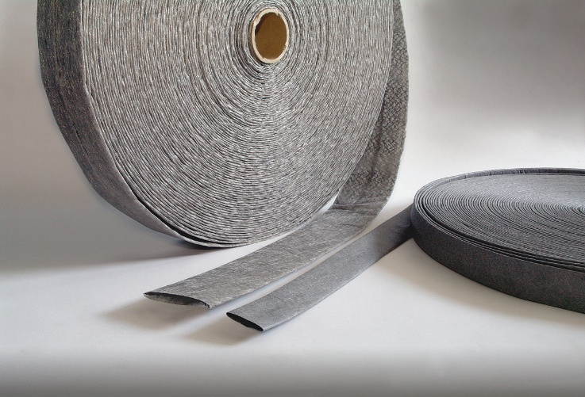
EnkaChannel.
Source: ©Freudenberg Performance Materials

Contact for media inquiries
Freudenberg Performance Materials Holding GmbH
Katrin Böttcher
Manager Global Media Relations
Höhnerweg 2-4 / 69469 Weinheim / Germany
Phone +49 6201 7107 014
Katrin.Boettcher@freudenberg-pm.com
www.freudenberg-pm.com

About Freudenberg Performance Materials
Freudenberg Performance Materials is a leading global supplier of innovative technical textiles for a broad range of markets and applications such as apparel, automotive, building interiors, building materials, healthcare, energy, filter media, shoe and leather goods as well as specialties. In 2023, the company generated sales of more than €1.4 billion, had 32 production sites in 14 countries around the world and had more than 5.000 employees. Freudenberg Performance Materials attaches great importance to social and ecological responsibility as the basis for its business success. For more information, please visit www.freudenberg-pm.com.
In 2023, the Freudenberg Group employed more than 52,000 people in around 60 countries worldwide and generated sales of some €11,9 billion. For more information, please visit www.freudenberg.com.

