PRESS RELEASE

2025 International Battery Seminar in Orlando: Freudenberg to present innovative battery separator solutions for stationary energy storage systems and further applications

Weinheim, February 6, 2025. Freudenberg Performance Materials (Freudenberg) will be showcasing its nonwoven battery separators at the International Battery Seminar in Orlando, Florida, USA, from March 17-20, 2025. The leading manufacturer of technical textiles will present innovative materials that enable long-duration, high-performance and safe stationary energy storage systems. The experts from Freudenberg look forward to meeting visitors at booth #103.

Freudenberg will present its range of battery separators that increase the cycle-life, performance and safety of batteries for stationary energy storage systems, as well as batteries used in transportation, communications and computer systems. This includes nickel-cadmium, nickel-metal hydride, nickel-zinc, nickel-hydrogen, metal-air and lead-acid batteries plus many more.
A wide range of solutions thanks to the broad technology platform
One highlight for visitors will be the latest unique surface finishing technology from Freudenberg that provides excellent electrolyte absorption as well as increasing the speed. The company combines this new finishing and a variety of other finishes with its versatile nonwoven technologies to develop further custom-made separators that meet the needs of energy storage system manufacturers and other battery manufacturers in the aviation, rail vehicle construction or computer systems sectors. Freudenberg has the broadest range of nonwoven technologies in the industry, including wetlaid, drylaid and spunbond processes. These offer unique capabilities to tailor material homogeneity and uniformity, electrolyte absorption, wicking rate, air permeability, thickness and tensile strength.
With production sites on several continents, Freudenberg can manufacture locally and offer major battery manufacturers optimal service.
The role of Freudenberg separators
Freudenberg high-performance nonwoven separators play an important functional role in batteries. Besides their primary function of separating the electrode and cathode, Freudenberg separators form an electrolyte reservoir in the battery, and contribute to enhancing battery functionality, self-discharge, and durability. What is more, they help to prevent short circuits by avoiding dendrite growth.

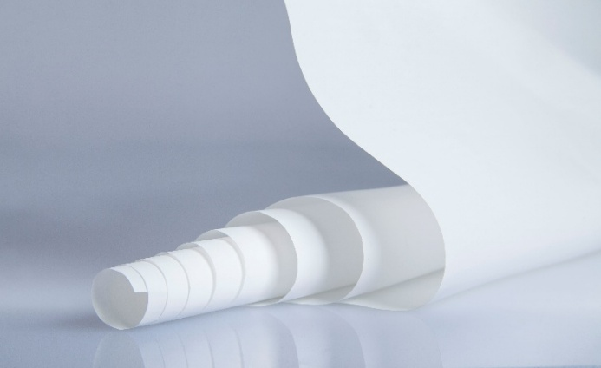
Freudenberg battery separator material
Source: ©Freudenberg Performance Materials

Contact for media inquiries
Freudenberg Performance Materials Holding GmbH
Katrin Böttcher  Manager Global Media Relations  Höhnerweg 2-4 / 69469 Weinheim / Germany  Phone +49 6201 7107 014  Katrin.Boettcher@freudenberg-pm.com  www.freudenberg-pm.com | Annalena Wahlig  Specialist Marketing & Communications  Höhnerweg 2-4 / 69469 Weinheim / Germany  Phone +49 174 1633978  Annalena.Wahlig@freudenberg-pm.com  www.freudenberg-pm.com

About Freudenberg Performance Materials
Freudenberg Performance Materials is a leading global supplier of innovative technical textiles for a broad range of markets and applications such as apparel, automotive, building interiors, building materials, healthcare, energy, filter media, shoe and leather goods as well as specialties. In 2023, the company generated sales of more than €1.4 billion, had 32 production sites in 14 countries around the world and had more than 5.000 employees. Freudenberg Performance Materials attaches great importance to social and ecological responsibility as the basis for its business success. For more information, please visit www.freudenberg-pm.com.
In 2023, the Freudenberg Group employed more than 52,000 people in around 60 countries worldwide and generated sales of some €11,9 billion. For more information, please visit www.freudenberg.com.

