PRESS RELEASE

Jens Reinig named new CFO at Freudenberg Performance Materials

Weinheim, March 25, 2025. Jens Reinig, currently Senior Vice President (SVP) Finance & Controlling at Freudenberg Performance Materials, has been appointed Chief Financial Officer (CFO) at Freudenberg Performance Materials effective April 1, 2025. He succeeds Marco Altherr, who is leaving the Freudenberg Group at his own request with effect from March 31, 2025, to take on new challenges outside the company.
“I greatly appreciated my collaboration with Marco Altherr on the management board of Freudenberg Performance Materials, both on a professional and a personal level. He made a significant contribution to the success of our company and introduced valuable forward-looking initiatives,” CEO Dr. Andreas Raps said. “Jens Reinig has many years of management experience and a deep understanding of our business. He will generate further valuable input in his role as CFO. I am looking forward to our close cooperation and to shaping the future of our company together,” Raps added.

Jens Reinig joined the Freudenberg Group in 2008 as team leader in Corporate Controlling at Freudenberg Nonwovens, the predecessor organization of Freudenberg Performance Materials. He subsequently held various positions in the company’s Finance & Controlling department. He became SVP Finance & Controlling at Freudenberg Performance Materials in 2020, holding this role until his recent appointment to the management board. Jens Reinig graduated from the University of Mannheim with a degree in business administration.

Effective April 1, 2025, the management board of Freudenberg Performance Materials comprises three members: Dr. Andreas Raps (CEO), Jens Reinig (CFO) and John McNabb (CTO).

Photo:
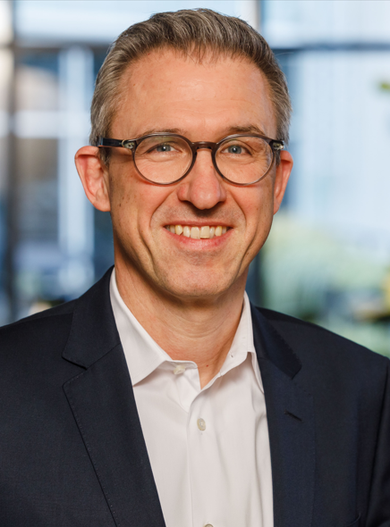
Jens Reinig has been appointed CFO at Freudenberg Performance Materials from April 1, 2025.
Source: ©Freudenberg Performance Materials

Contact for media inquiries
Freudenberg Performance Materials Holding GmbH
Katrin Böttcher  Manager Global Media Relations  Höhnerweg 2-4 / 69469 Weinheim / Germany  Phone +49 6201 7107 014  Katrin.Boettcher@freudenberg-pm.com  www.freudenberg-pm.com | Annalena Wahlig  Specialist Marketing & Communications  Höhnerweg 2-4 / 69469 Weinheim / Germany  Phone +49 6201 7107 405  Annalena.Wahlig@freudenberg-pm.com  www.freudenberg-pm.com

Über Freudenberg Performance Materials
Freudenberg Performance Materials is a leading global supplier of innovative technical textiles for a broad range of markets and applications such as apparel & shoe, building, civil engineering, energy, filtermedia, healthcare, household & living, industrial & manufacturing, mobility & transport, as well as coated technical textiles. In 2024, the company generated sales of more than €1.4 billion, operated 35 production sites in 14 countries around the world and had around 5,000 employees. Freudenberg Performance Materials attaches great importance to social and ecological responsibility as the basis for its business success. For more information, please visit www.freudenberg-pm.com

In 2024, the Freudenberg Group employed over 52,100 people in around 60 countries worldwide and generated sales of some €11.9 billion. For more information, please visit www.freudenberg.com

