**PRESS RELEASE**

**IDEA Show 2025: Freudenberg presents a diverse portfolio of high-performance solutions**

**Weinheim, April 8, 2025. Freudenberg Performance Materials (Freudenberg) is presenting a wide range of advanced solutions for numerous industries and markets at this year's IDEA Show in Miami Beach, Florida, USA. These include innovative applications for filtration, construction, energy, cleaning, composites, printing and healthcare as well as for the packaging industry. The Freudenberg experts look forward to welcoming visitors to**   
**booth # 3234 from April 29 to May 1, 2025.**

The Freudenberg stand at this year's IDEA Show will feature a wide range of nonwoven solutions and technologies: from surface nonwovens for improved corrosion resistance, battery separator solutions that increase the life cycle, performance and safety of energy storage systems to the innovative Enka® solutions for pre-vegetated green roof constructions.

**Flexible wetlaid technology for filtration, energy and more**

One highlight of this year's IDEA Show are the many different applications of Freudenberg’s unique wetlaid technology, which allows for a high level of customization together with a wide range of technical possibilities in weights, types of fibers and compositions. Thanks to the high versality of its production lines and product range, Freudenberg can meet the needs of key wetlaid markets: filtration, building & construction, energy and packaging.

At IDEA Freudenberg will present, among other things, its wetlaid solutions in the field of sound absorption in buildings, as well as for diverse markets such as energy, composites and horticulture. Battery separators based on wetlaid nonwoven technology increase the life cycle and safety of energy storage systems. In the composite industry, Freudenberg surfacing veils ensure abrasion resistance, corrosion protection, smooth surfaces, and enhanced mechanical strength for fiber-reinforced plastics. In addition, Freudenberg will present its bio-based materials, which are ideal for biodegradable plant propagation systems.

Alongside the wetlaid nonwovens, the Freudenberg experts will also be showcasing their innovations in fine denier spunbond technology.

**Enka®Solutions:** **Adapting to the changing construction industry**

Another highlight of Freudenberg’s portfolio at the IDEA Show are the Enka®Solutions applications tailored to the roofing and construction market. For example, the Enka® BioCarrier that is particularly suitable for green roofs will be on display. The carrier material from Freudenberg enables pre-vegetated green roof constructions and consists of 100% bio-based raw materials. Green roofs are becoming increasingly popular due to their numerous ecological and financial benefits. Enka®Solutions green roof applications thus enable customers to meet the changing demands of the construction sector while maintaining a strong commitment to sustainability.

**Photos:**

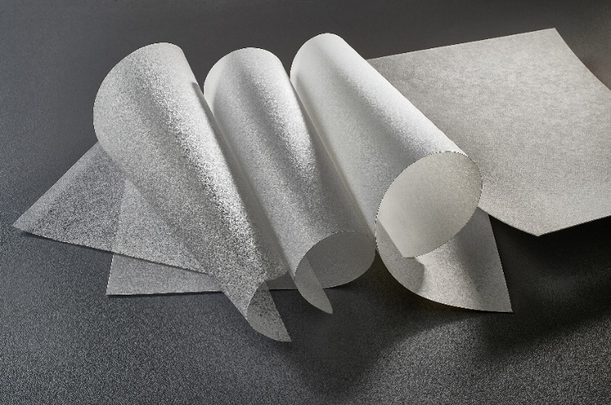

Freudenberg's wetlaid materials.

Source: ©Freudenberg Performance Materials

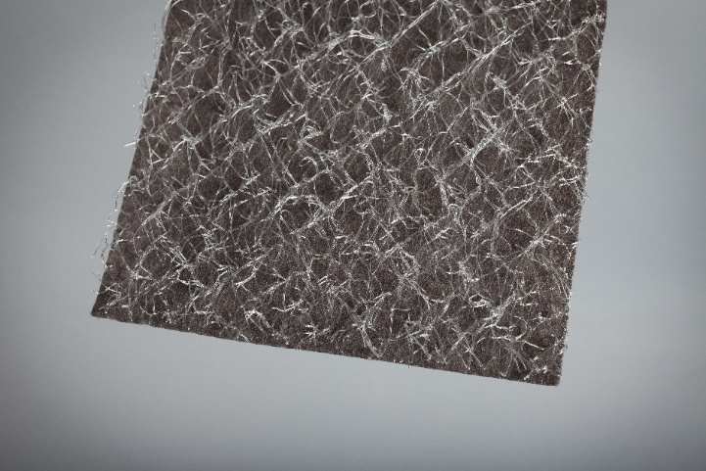

Freudenberg´s carrier material for green roofs.

Source: ©Freudenberg Performance Materials

**Contacts for media inquiries**

**Freudenberg Performance Materials Holding GmbH**

|  |  |
| --- | --- |
| Katrin Böttcher  Manager Global Media Relations  Höhnerweg 2-4 / 69469 Weinheim / Germany  Phone +49 6201 7107 014  [Katrin.Boettcher@freudenberg-pm.com](mailto:Katrin.Boettcher@freudenberg-pm.com)  [www.freudenberg-pm.com](https://www.freudenberg-pm.com) | Annalena Wahlig  Specialist Marketing & Communications  Höhnerweg 2-4 / 69469 Weinheim / Germany  Phone +49 6201 7107 405  [Annalena.Wahlig@freudenberg-pm.com](mailto:Annalena.Wahlig@freudenberg-pm.com)  [www.freudenberg-pm.com](https://www.freudenberg-pm.com) |

**About Freudenberg Performance Materials**

Freudenberg Performance Materials is a leading global supplier of innovative technical textiles for a broad range of markets and applications such as apparel & shoe, building, civil engineering, energy, filtermedia, healthcare, household & living, industrial & manufacturing, mobility & transport, as well as coated technical textiles. In 2024, the company generated sales of more than €1.4 billion, operated 35 production sites in 14 countries around the world and had around 5,000 employees. Freudenberg Performance Materials attaches great importance to social and ecological responsibility as the basis for its business success. For more information, please visit www.freudenberg-pm.com

In 2024, the Freudenberg Group employed over 52,100 people in around 60 countries worldwide and generated sales of some €11.9 billion. For more information, please visit www.freudenberg.com