PRESS RELEASE

Freudenberg Performance Materials unveils versatile innovative fine denier spunbond nonwovens for applications in construction, filtration, coating and other industries

Weinheim, April 22, 2025. The unique fine filament nonwoven technology from Freudenberg Performance Materials (Freudenberg) is made from a wide variety of polymers and blends using mono or bico fibers. The high flexibility and broad customization options provide benefits in a wide range of markets and applications – from roofing membranes to liquid filtration, as well as specific applications such as dehumidification products and artificial turf.
Freudenberg’s innovative fine denier spunbond materials rely on flexible manufacturing capabilities, which enable a high level of customization. They can be made of PET, PE or PP, not only as 100% composition but also in many different combinations, e.g. PET/PE, PET/coPET or PET/mPP, using mono or bico fibers with titer ranging from 2.5 to 3 dtex. The material weight spans 17 to 140gsm. The nonwovens are strongly bonded thanks to thermal bonding provided either by flat calendering or point sealing. The technology enables lightweight solutions with high tensile and tear strength, as well as a smooth and uniform surface.
Special advantages for the construction industry
Ideally suited for construction applications such as roofing & facade membranes, vapor barriers and house wrappings, Freudenberg lightweight fine denier nonwovens complement the well-known Terbond®, Texbond® and Colback® solutions for the construction market. They deliver mechanical strength and, in particular, a high nail tear strength as required by the market. Moreover, they have high UV and temperature resistance and stability thanks to the PET composition.
Filtration applications
The fine denier technology is also marketed under the Filtura® brand, specifically suited for liquid filtration, e.g. coolants & lubricants. The technology provides high efficiency and a regular surface, as well as new capabilities with PET-PA and PET-PE nonwovens. Support media applications for glass fiber, nano and activated carbon also benefit from the lightweight fine denier nonwovens as protective layers.
Efficient converting and high durability for packaging and coating
The fully synthetic PET/PE fine denier materials are ideal for packaging applications such as desiccant bags and other dehumidifier products. They enable the efficient and fast production of such pouches due to their exceptional hot sealing capabilities, with no need for chemical binders or additional treatments. Freudenberg’s technology provides high strength, high abrasion resistance and high durability, allowing for long-lasting desiccant bags.
In the coating industry, too, Freudenberg’s fine denier spunbonds contribute to enhanced process efficiency. The materials are chemically resistant and have good thermal stability. High-quality coating results can be achieved by using these materials as coating substrates, thanks to their smooth and even surface. The material properties can be customized for coating, laminating and concealing applications thanks to different combinations of polymers, fiber types and bonding technologies. For example, a specific very lightweight flat bonded variant of the material is an ideal coating substrate for cold wax depilatory strips, providing the necessary high mechanical strength and material flexibility.
Other applications for Freudenberg’s fine filament technology are crop covers in agriculture, decoration applications and other industrial or consumer applications.

Photos:
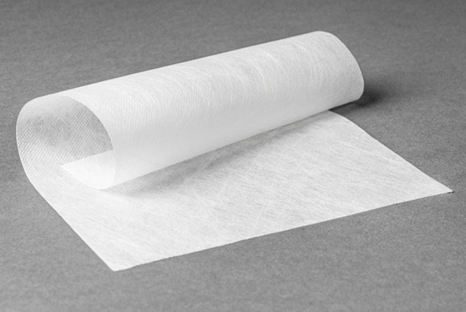
PET/PE fine denier spunbond for desiccant bags from Freudenberg Performance Materials.

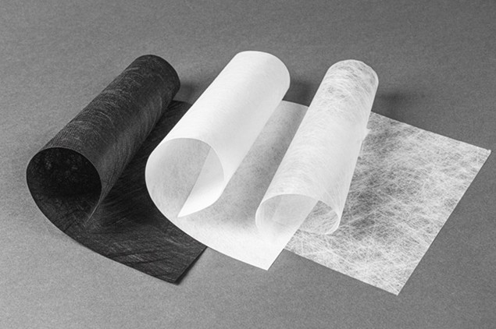
Examples of PET fine denier spunbond nonwovens from Freudenberg Performance Materials.

Contact for media inquiries
Freudenberg Performance Materials Holding GmbH
Katrin Böttcher  Manager Global Media Relations  Höhnerweg 2-4 / 69469 Weinheim / Germany  Phone +49 6201 7107 014  Katrin.Boettcher@freudenberg-pm.com  www.freudenberg-pm.com | Annalena Wahlig  Specialist Marketing & Communications  Höhnerweg 2-4 / 69469 Weinheim / Germany  Phone +49 6201 7107 405  Annalena.Wahlig@freudenberg-pm.com  www.freudenberg-pm.com

About Freudenberg Performance Materials
Freudenberg Performance Materials is a leading global supplier of innovative technical textiles for a broad range of markets and applications such as apparel & shoe, building, civil engineering, energy, filtermedia, healthcare, household & living, industrial & manufacturing, mobility & transport, as well as coated technical textiles. In 2024, the company generated sales of more than €1.4 billion, operated 35 production sites in 14 countries around the world and had around 5,000 employees. Freudenberg Performance Materials attaches great importance to social and ecological responsibility as the basis for its business success. For more information, please visit www.freudenberg-pm.com
In 2024, the Freudenberg Group employed more than 52,000 people in around 60 countries worldwide and generated sales of some €11.9 billion. For more information, please visit www.freudenberg.com

